

Software Requirement Specification

**FPT Education Learning Materials (FLM)**

**Version: 1.2**

– Hanoi, June 2023 –

# Record of Changes

| **Version** | **Date** | **A* M, D** | **In charge** | **Change Description** |
| --- | --- | --- | --- | --- |
| V1.0 | 24/06 | A | TrungVK | Add context Diagram |
|  | 24/06 | A | DungLM | Draw and write feature tree |
|  | 25/06 | A | NamDH | Non-functional requirement |
|  | 26/06 | A | TrungVK | Add screenflow, Curriculum management UCs, Syllabus management Ucs |
|  | 26/06 | A | TrungVK | Add Actor List |
|  | 26/06 | A | SonNN | Screen List, Login System UC, Subject Management UCs |
|  | 26/06 | A | DanBS | Add screenflow, Combo Management UCs,Elective Management UCs |
|  | 26/66 | A | DungLM | Syllabus CLO Management UCs, Syllabus Assessment Management UCs |
|  | 26/06 | A | NamDH | Curriculum Subject UCs,Curriculum Subject PLO UCs |
| v1.1 | 29/06 | M | TrungVK | Curriculum Management UCs, Syllabus management Ucs, |
|  | 29/06 | M | NamDH | Curriculum Subject UCs,Curriculum Subject PLO UCs |
|  | 29/06 | M | SonNN | Login System UC, Subject Management UCs |
|  | 29/06 | M | DungLM | Feature tree |
|  | 29/06 | M | DanBS | Add screenflow,Elective Management UCs |
|  | 29/06 | M | DanBS | Add screenflow, Combo Management UCs |
|  | 29/06 | A | TrungVK | System ERD |
| v1.2 | 05/07 | M | TrungVK | Curriculum Management UCs, Syllabus management Ucs, |
|  | 06/07 | M | NamDH | Curriculum Subject UCs,Curriculum Subject PLO UCs |
|  | 06/07 | M | DanBS | Add screenflow,Elective Management UCs |
|  | 06/07 | M | SonNN | Login System UC, Subject Management UCs |
|  | 06/07 | M | DungLM | Syllabus CLO Management UCs, Syllabus Assessment Management UCs |
|  |  |  |  |  |
|  |  |  |  |  |
|  |  |  |  |  |
|  |  |  |  |  |

*A - Added M - Modified D - Deleted

Contents

Record of Changes 2

I. Overall Requirements 5

1. Context Diagram 5

2. Features Tree 6

3. System Actors 6

3.1 Actors List 6

3.2 UC Diagrams 7

4. Use Cases (UCs) 12

4.1 UCs List 12

4.2 UC Diagrams 12

5. Function Overview 17

5.1 Screen Flow 17

5.2 Screens List 17

5.3 Authorization 19

5.4 Non-UI Functions 20

6. Data Requirement 20

6.1 System ERD 21

II. Functional Requirements 22

1. Login System UC 22

1.1. UC01 - Login System 22

1.2. UC02 – Reset Password 25

1.3. UC03 - Register User Account 28

2. Subject Management UCs 31

2.1 UC04 - View Subject List 31

2.2. UC05 –Add New Subject 33

2.3. UC06- Update Subject 35

3. Curriculum Management UCs 37

3.1. UC07 – View Curriculum List 37

a. Activity Diagram 37

3.2. UC08 - Add New Curriculum 40

3.3. UC09- Update Curriculum 43

4. Syllabus Management UCs 46

4.1. UC010 - View Syllabus List 46

4.2 UC011 - Add New Syllabus 49

4.3 UC012 - Update Syllabus 52

5. Syllabus CLO Management UCs 55

5.1. UC013 - View Syllabus CLO List 55

5.2 UC014 - Update Syllabus CLO 58

5.3 UC015 - Add New Syllabus CLO 61

6. Syllabus Assessment Management UCs 64

6.1. UC016 - View Assessment Syllabus List 64

6.2 UC017 - Update Assessment Syllabus 67

6.3 UC018 - Add New Assessment Syllabus 70

7. Combo Management UCs 73

7.1. UC019 - View Combo List 73

7.2 UC020 - Update Combo 76

7.3 UC021 - Add New Combo 79

8. Elective Management UCs 82

8.1. UC022 - View Elective List 82

8.2 UC023 - Update Elective 85

8.3 UC024 - Add New Elective 88

9. Curriculum Subject UCS 91

9.1. UC025 - View Curriculum Subject List 91

9.2 UC026 - Update Curriculum Subject 94

9.3 UC027 - Add Curriculum Subject 97

10. Curriculum Subject PLO UCs 100

10.1. UC028 - View Curriculum Subject PLO List 100

10.2 UC029 - Update Curriculum Subject PLO 103

10.3 UC030 - Add Curriculum Subject PLO 106

III. Non-Functional Requirements 108

1. External Interfaces 108

1.1 User Interfaces 108

1.2 Software Interfaces 108

1.3 Hardware Interfaces 108

1.4 Communications Interfaces 109

2. Quality Attributes 109

2.1 Usability 109

2.2 Security 109

2.3 Performance 109

2.4 Safety Requirements 109

IV. Appendix 109

1. Assumptions & Dependencies 109

2. Limitations & Exclusions 110

3. Business Rules 110

# I. Overall Requirements

## 1. Context Diagram

- New FLM is software written for university which provides the capabilities of :

• Browsing learning/teaching materials to the public (guests), students, and teachers.

• Managing, designing, and reviewing materials and related information to the CRDD Heads (the leaders of CRDD), CRDD staff, syllabus designers, and syllabus reviewers.

• System administration features to the system admins.

- The human actors of this system are as listed above. As the Syllabus Designer & Syllabus Review might be the external users who do not have FPT account to login the system using Google Login, the separated user registering, verifying and logging in features are needed for them to login.

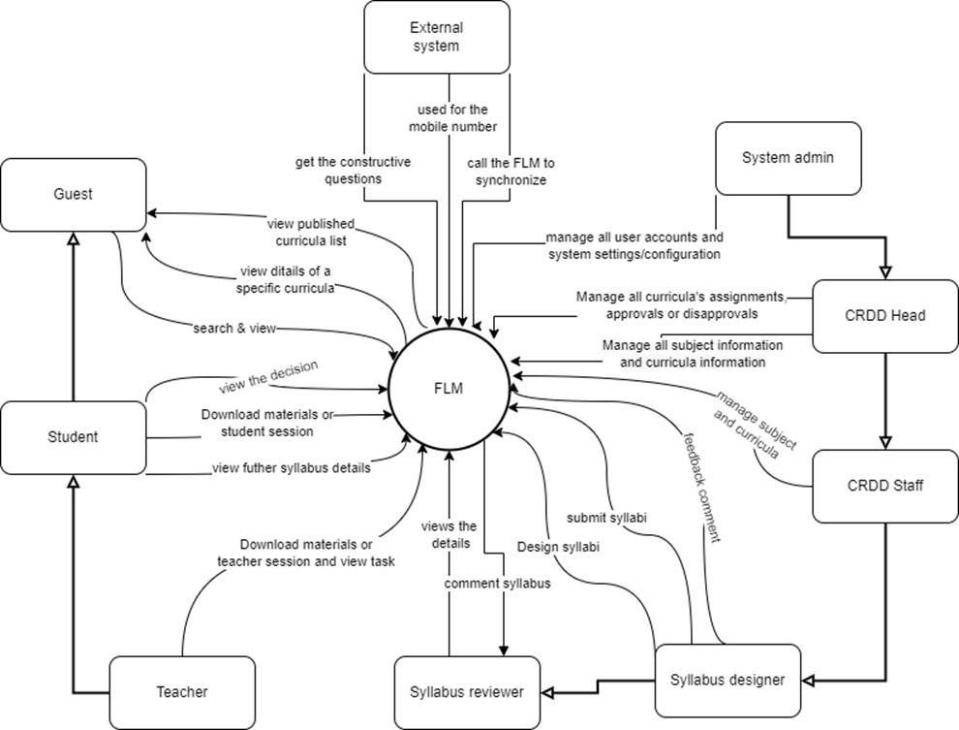

F1. Context diagram

## 2. Features Tree

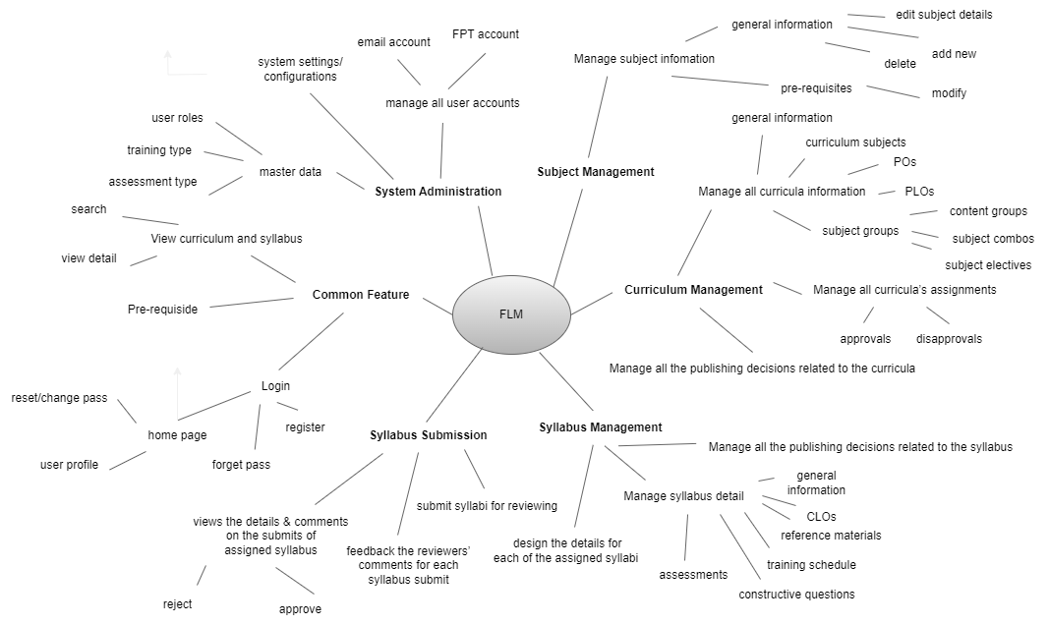

## 3. System Actors

### 3.1 Actors List

| No | Actors | Actors Details |
| --- | --- | --- |
| 1 | Guest | A user who has limited access to the system without logging in or creating an account. |
| 2 | Teacher | A user who has logged in as a teacher. |
| 3 | Student | A user who has logged in as a student. |
| 4 | Syllabus review | A user who reviews and provides feedback on syllabus submissions. |
| 5 | Syllabus designer | A user who designs syllabi and submits them for review. |
| 6 | CRDD Staff | Staff members responsible for managing curricula, syllabi, and publishing decisions |
| 7 | CRDD Head | A user who manages all subjects and curriculum. |
| 8 | Admin | A user who manages all user accounts , system and data. |

### 3.2 UC Diagrams

#### a. Guest

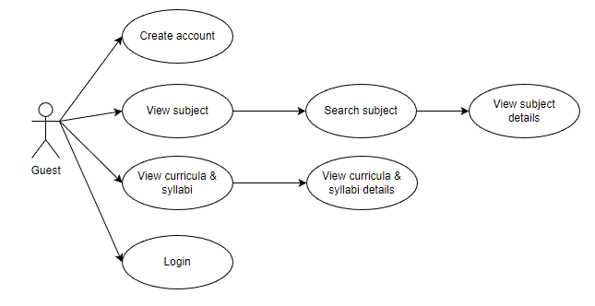

#### b. Student

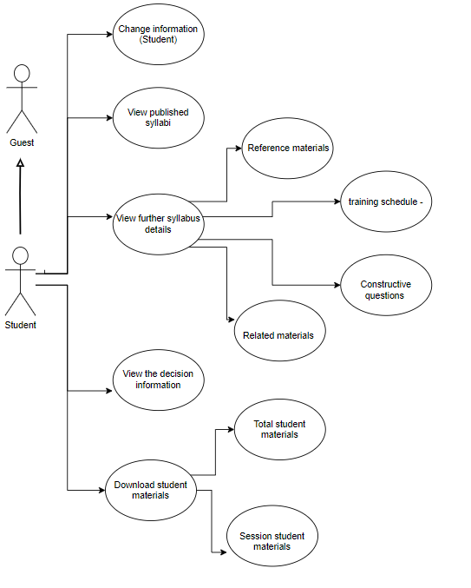

#### c. Teacher

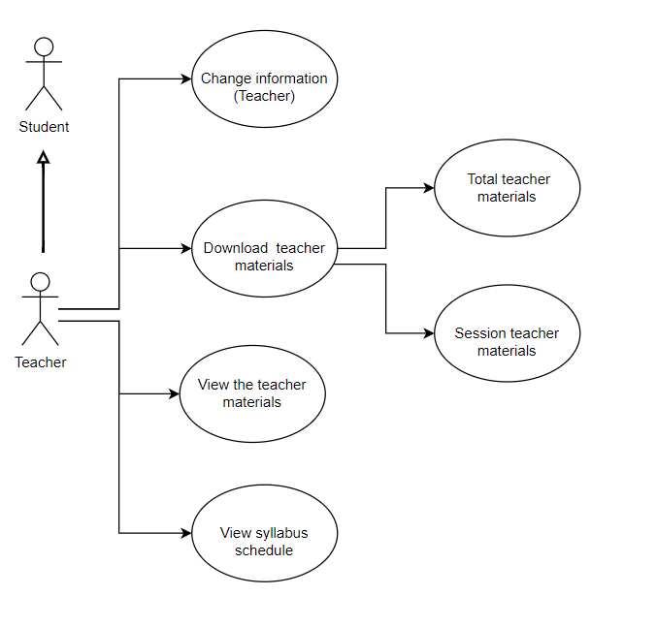

#### d. Syllabus review

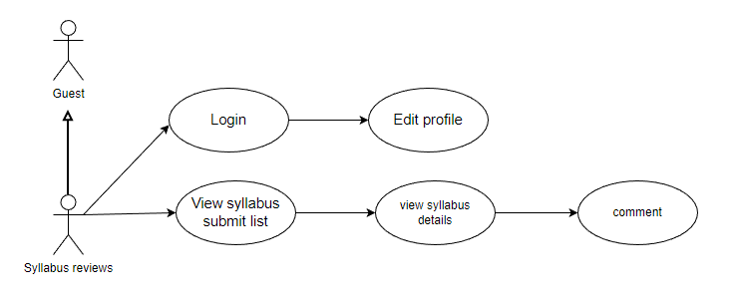

#### e. Syllabus designer

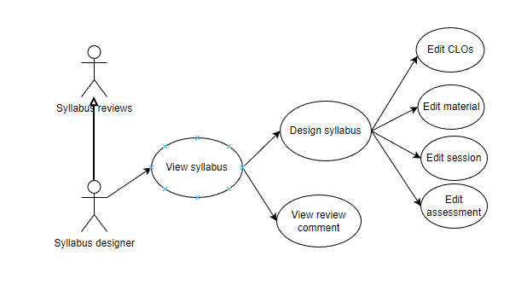

#### f. CRDD Staff

#### g. CRDD Head

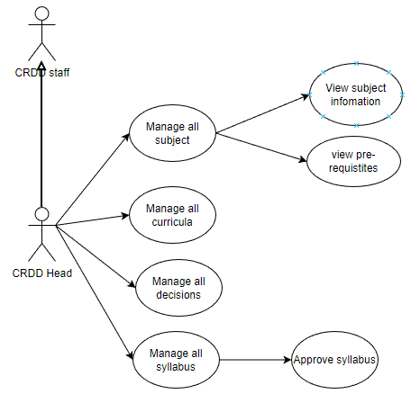

#### h. Admin

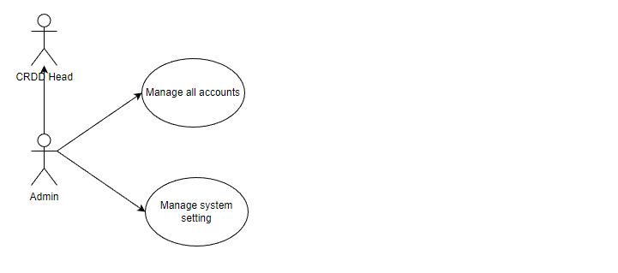

## 4. Use Cases (UCs)

### 4.1 UCs List

### 4.2 UC Diagrams

#### a. Subject Management

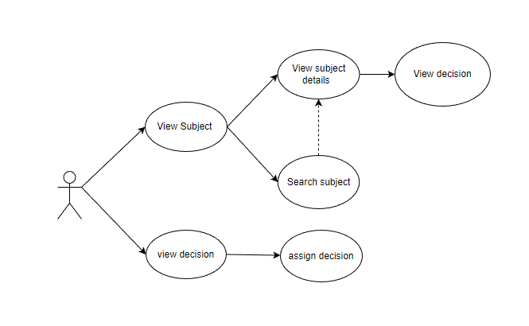

#### b. Curriculum Management

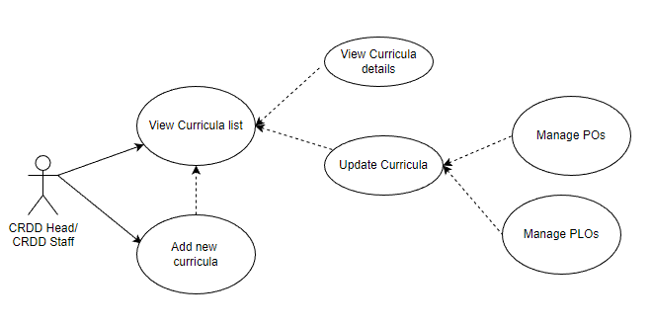

#### c. Syllabus Management

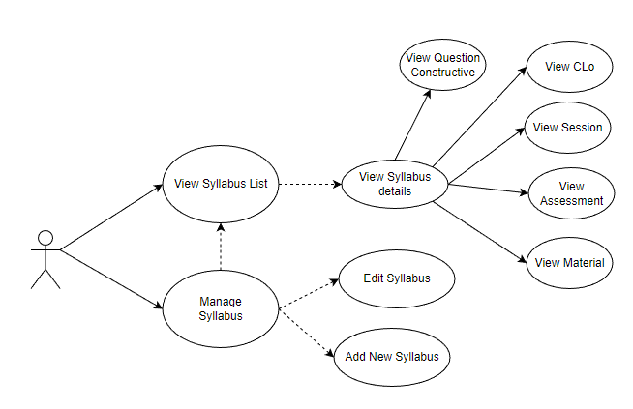

#### d. Syllabus Submission

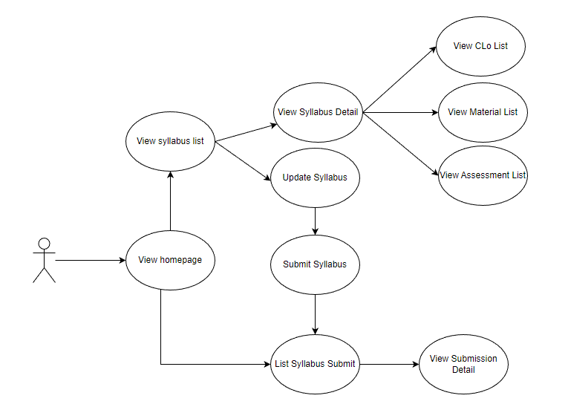

#### e. Common Feature

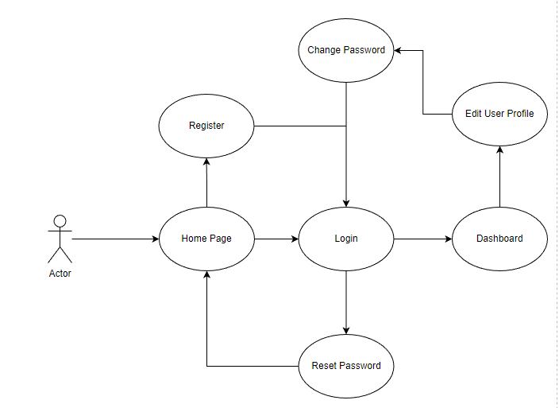

#### f. System Administration

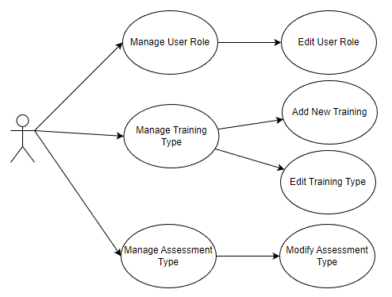

## 5. Function Overview

### 5.1 Screen Flow

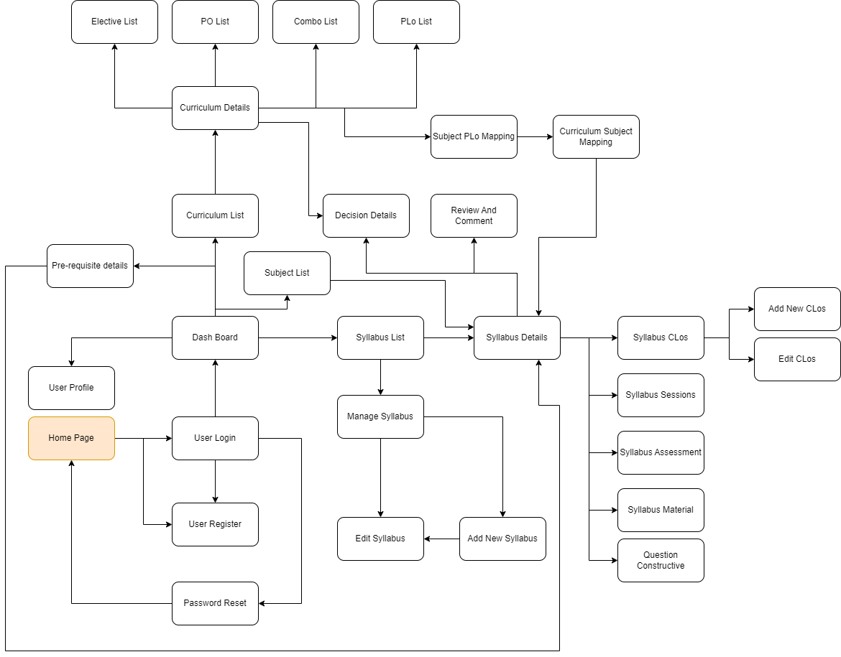

### 5.2 Screens List

| # | Screen | Screen Detail |
| --- | --- | --- |
| 1 | Home Page | User can View Curriculum, View Syllabus, Show Learning Path of a Subject, A subject is the pre-requisite of, account setting |
| 2 | User Login | User can login with google account or Syllabus Reviewer/Designer account |
| 3 | User Register | User can send a request to admin |
| 4 | Password Reset | User can change password or retrieve password by entering email to receive code |
| 5 | DashBoard | User Information, System Overview, Quick Links, Recent Activity, Notifications, Analytics and Reports |
| 6 | User Profile | add a personal account so you still have access to FLM after leaving your education system |
| 7 | Curriculum List | Enter subject code to search Curriculum List |
| 8 | Curriculum Detail | See Curriculum Details, Mapping subjects of the Curriculum to program learning outcomes, PLO, subject, View PO, View Combo, View Elective |
| 9 | Elective List | View Elective Management such as Elective ID, Elective Name, Subject |
| 10 | PO List | Display PO list, Search for PO, View PO details, Modify PO, Delete PO, Create a new PO, Manage PO status |
| 11 | Combo List | View Combo Management as Combo ID, Combo Name |
| 12 | PLo List | View details PLO Name, PLO Description |
| 13 | Subject PLo Mapping | Display Subject PLo Mapping list, Add new Subject PLo Mapping, View Subject PLo Mapping details, Search, Edit, Delete Subject PLo Mapping |
| 14 | Curriculum Subject Mapping | View General knowledge and skills, Major knowledge and skills, Specialized knowledge and skills, Elective combo knowledge and skills |
| 15 | Decision Details | Help capture important information about a decision and facilitate understanding and re-evaluation of the decision in the future |
| 16 | Subject List | Show all subject |
| 17 | Syllabus List | Show all syllabus |
| 18 | Manage Syllabus | Enter subject code to search syllabus subject |
| 19 | Add New Syllabus | Add a new syllabus |
| 20 | Edit Syllabus | Add, edit, delete syllabus |
| 21 | Syllabus Detail | View syllabus Details, Materials, LO, Sessions, Constructive Question, Assessment |
| 22 | Syllabus CLos | View CLO Name, CLO Details, LO Details |
| 23 | Syllabus Sessions | View Session, Topic, Learning-Teaching Type, CLO, ITU, Student Materials, S-Download, Student's Tasks, URLs |
| 24 | Syllabus Assessment | View Category, Type, Part, Weight, Completion Criteria, Duration, CLO, Question Type, No Question, Knowledge and Skill, Grading Guide, Note |
| 25 | Syllabus Material | View Material Description, Author, Publisher, PublishedDate, Edition, ISBN, IsMainMaterial, IsHardCopy, IsOnline, Note |
| 26 | Question Constructive | View Session No, Name, Details |
| 27 | Add New CLO(s) | Add a new CLO(s) |
| 28 | Edit CLO(s) | Add, edit, delete, CLO(s) |
| 29 | Pre-requisite details | View subject pre - requisite list for a subject |

### 5.3 Authorization

| **Screen** | **Admin** | **Teacher** | **Student** | **CRDD Head** | **CRDD Staff** | **Syllabus Designer** | **Syllabus Reviewer** | **Guest** |
| --- | --- | --- | --- | --- | --- | --- | --- | --- |
| Home Page | x | x | x | x | x | x | x | x |
| User Login | x | x | x | x | x | x | x |  |
| User Register |  |  |  |  |  |  |  | x |
| Password Reset | x | x | x | x | x | x | x |  |
| DashBoard | x | x | x | x | x | x | x |  |
| User Profile | x | x | x | x | x | x | x |  |
| Curriculum List | x | x | x | x | x | x | x | x |
| Curriculum Detail | x | x | x | x | x | x | x | x |
| Elective List | x | x | x | x | x | x | x | x |
| PO List | x | x | x | x | x | x | x | x |
| Combo List | x | x | x | x | x | x | x | x |
| PLo List | x | x | x | x | x | x | x | x |
| Subject PLo Mapping | x | x | x | x | x | x | x | x |
| Curriculum Subject Mapping | x | x | x | x | x | x | x | x |
| Decision Details | x | x | x | x | x | x | x |  |
| Subject List | x | x | x | x | x | x | x | x |
| Syllabus List | x | x | x | x | x | x | x | x |
| Manage Syllabus | x |  |  | x | x | x |  |  |
| Add New Syllabus | x |  |  | x | x | x |  |  |
| Edit Syllabus | x |  |  | x | x | x |  |  |
| Syllabus Detail | x | x | x | x | x | x | x |  |
| Syllabus CLos | x | x | x | x | x | x | x |  |
| Syllabus Sessions | x | x | x | x | x | x | x |  |
| Syllabus Assessment | x | x | x | x | x | x | x |  |
| Syllabus Material | x | x | x | x | x | x | x |  |
| Question Constructive | x | x | x | x | x | x | x |  |
| Add New CLos | x |  |  | x | x | x |  |  |
| Edit CLos | x |  |  | x | x | x |  |  |
| Pre-requisite details | x | x | x | x | x | x | x | x |

### 5.4 Non-UI Functions

|  | Feature | System Function | Description |
| --- | --- | --- | --- |
| 1 | Sign out | Common | The function to log out or terminate the current user session |
| 2 | Search | Common | This function allow user search about subject , curriculum, etc |
| 3 | Download material | Common | This function allow user download material from syllabus or subject |

## 6. Data Requirement

### 6.1 System ERD

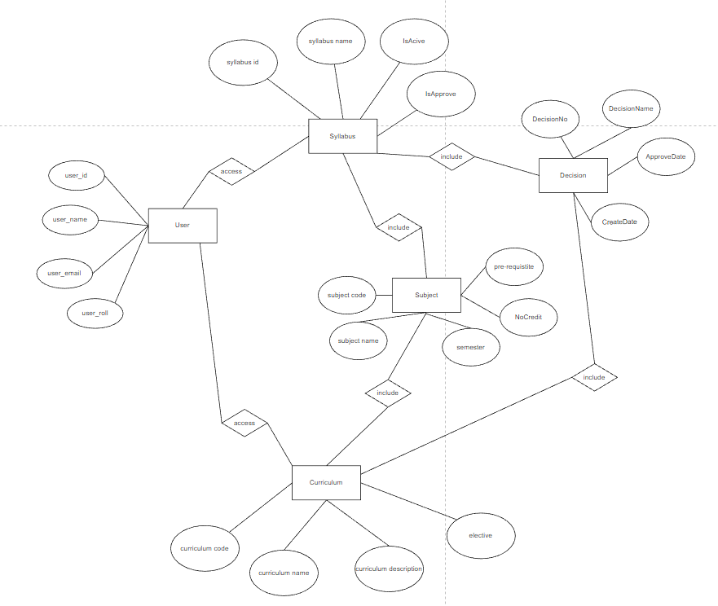

# II. Functional Requirements

## 1. Login System UC

### 1.1. UC01 - Login System

#### a. Activity Diagram

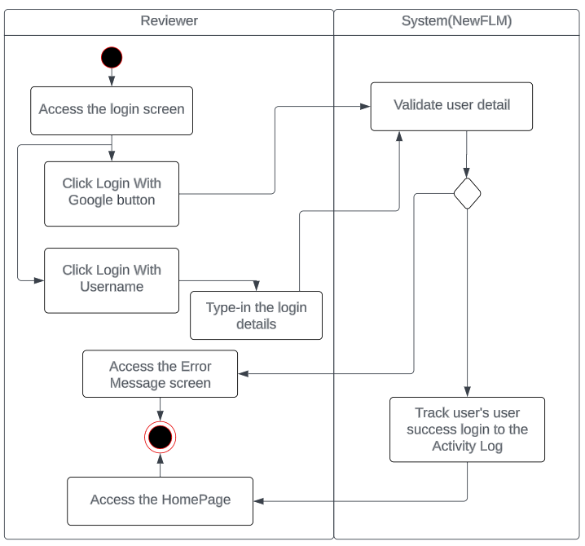

#### b. Prototype/Mockup

##### Login with Google screen

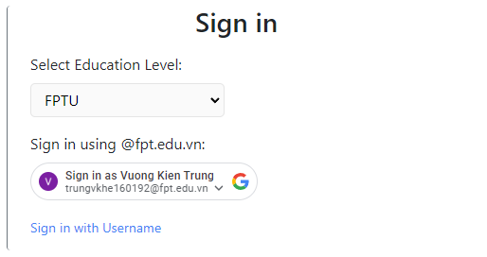

| **Field Name** | **Field Type** | **Description** |
| --- | --- | --- |
| Email* | Text Box | This is for user to input valid email address for logging in |
| Password* | Password Box | This is for user to input password for logging in |
| Login | Button | User clicks to authenticate him/herself into the system with provided email & password |
| Login with Google | Hyperlink | Allow user to login with his/her Google account |
| Login with Reviewer | Hyperlink | Allow user to login with Reviewer |

##### 

##### Login with username screen

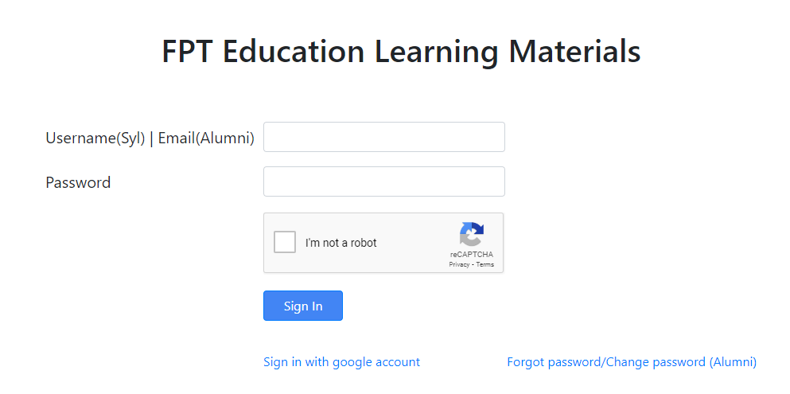

| **Field Name** | **Field Type** | **Description** |
| --- | --- | --- |
| Username/Email* | Text Box | This is for user to input valid username/email address for logging in |
| Password* | Password Box | This is for user to input password for logging in |
| Sign In | Button | User clicks to authenticate him/herself into the system with provided username/email & password |
| Forgot Password/Change Password | Hyperlink | User clicks to redirect to the Password Reset page for resetting his/her forgot password |
| Login with Google | Hyperlink | Allow user to login with his/her Google account |

#### c. Functional Description

| UC ID and Name: | **UC01 – Login System** | | | | | |
| --- | --- | --- | --- | --- | --- | --- |
| Created By: | SonNN | | Date Created: | 26/06/2023 | | |
| Primary Actor: | Student/Reviewer | | Secondary Actors: |  | | |
| Trigger: | Clicks Login with Google or login with username from the Default Sign In screen | | | | | |
| Description: | As a user, I want to be able to log into the system so that I can use the system’s authenticated features and access my personalized account. | | | | | |
| Preconditions: | User account has been created & authorized | | | | | |
| Postconditions: | * User logs in the system successfully * The system tracked successful login into the Activity Log | | | | | |
| Normal Flow: | ***Step*** | ***Step Details*** | | | ***By*** | ***Business Rules*** |
| 1 | Access the User Login screen | | | User |  |
| 2 | Login with Google | | | User |  |
| 3 | Click the Login button | | | User | FR1 |
| 4 | Validate login details | | | System |  |
| 5 | Allow user to access the system | | | System |  |
| 6 | Track user’s success login to the Activity Log | | | System |  |
| 7 | Access the Home Page | | | System |  |
| Alternative Flows: | ***Reviewer Login***  1. User chooses to login system using Reviewer account  2. System redirects the user to the Reviewer’s Login screen  3. User types in the account details and chooses to login  4. Validates user’s login information successfully and redirect him/her back to the system | | | | | |
| Exceptions: | ***System can’t authenticate the user***  1. The Error Message screen is shown to the user  2. User cancels the logging in *=> UC stops, change to Default Sign In*  3. User clicks “Forgot Password/Change Password” link *=> change to UC03-Reset Password*  4. User clicks “Register” link *=> change to UC03-Register User Account* | | | | | |
| Priority: | Must Have | | | | | |
| Frequency of Use: | None | | | | | |
| Business Rules: | BR1 | | | | | |
| Other Information: | None | | | | | |
| Assumptions: | None | | | | | |

#### d. Business Rules

| **ID** | **Business Rule** | **Business Rule Description** |
| --- | --- | --- |
| FR1 | Password Encoding | User’s password must be encoded |
| BR1 | Invalid Logging In | User can’t be authenticated to login the system if below cases  His/her logging-in details are incorrect  His/her account has not been verified  His/her account has been locked or blocked |

### 1.2. UC02 – Reset Password

#### a. Activity Diagram

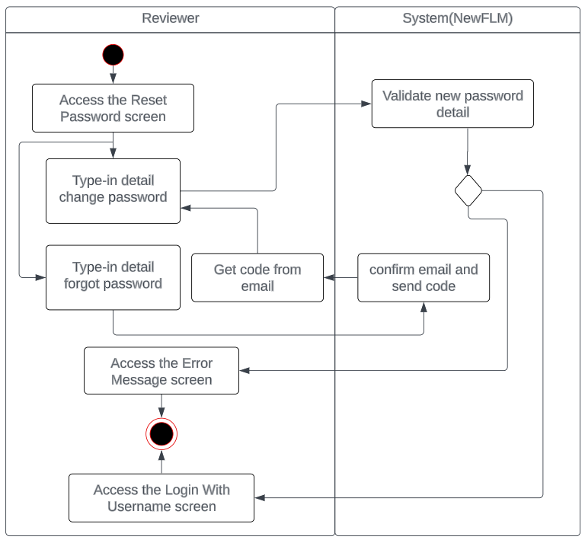

#### b. Prototype/Mockup

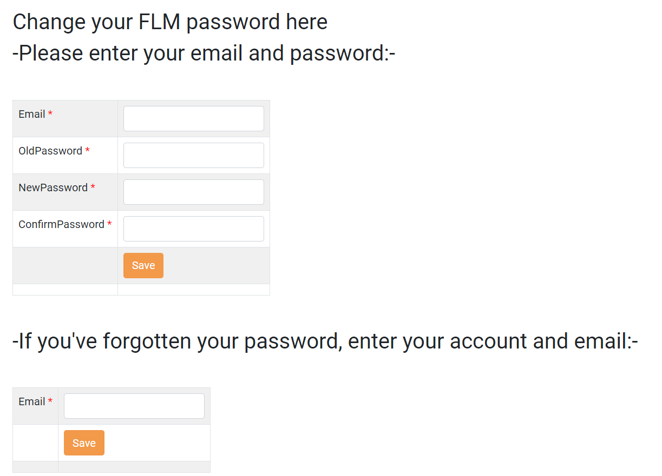

| **Field Name** | **Field Type** | **Description** |
| --- | --- | --- |
| Email* | Text Box | This is for user to input valid email address for change password |
| OldPassword* | Password Box | This is for users who enter their password before changing |
| NewPassword | Password Box | This is for users who enter their password after changing |
| ConfirmPassword | Password Box | This is for users who re-enter their password after changing |
| Save | Button | User clicks to change into the system with provided password |

##### 

#### c. Functional Description

| UC ID and Name: | **UC02 – Reset Password** | | | | | |
| --- | --- | --- | --- | --- | --- | --- |
| Created By: | SonNN | | Date Created: | 26/06/2023 | | |
| Primary Actor: | Reviewer | | Secondary Actors: |  | | |
| Trigger: | User clicks Forgot password/Change password from the Sign In screen | | | | | |
| Description: | As a user, I want to be able to change my password | | | | | |
| Preconditions: | User password has been changed | | | | | |
| Postconditions: | User changed password successfully | | | | | |
| Normal Flow: | ***Step*** | ***Step Details*** | | | ***By*** | ***Business Rules*** |
| 1 | Access Forgot password/Change password screen | | | User |  |
| 2 | Enter detail reset password | | | User |  |
| 3 | Click the save button | | | User |  |
| 4 | User password has been changed | | | System |  |
| Alternative Flows: | ***Forgot password***  1. User enter email  2. System sends a code to the email entered  3. User takes the code sent to change the new password  4. System authenticate successfully and change password successfully | | | | | |
| Exceptions: | ***System can’t authenticate***  1. The Error Message screen is shown to the user  2. User cancels reset password *=> UC stops, change to Sign In* | | | | | |
| Priority: | Must Have | | | | | |
| Frequency of Use: | None | | | | | |
| Business Rules: | None | | | | | |
| Other Information: | None | | | | | |
| Assumptions: | None | | | | | |

#### d. Business Rules

### 1.3. UC03 - Register User Account

#### a. Activity Diagram

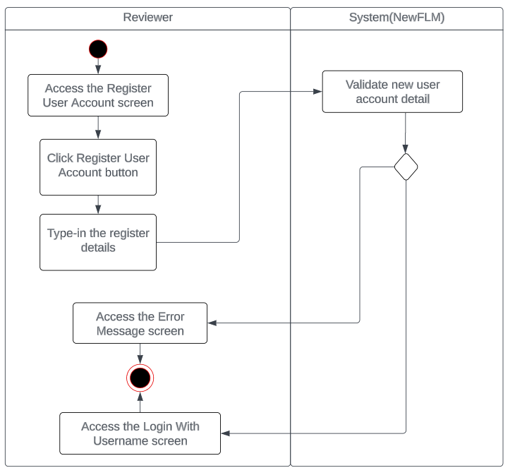

#### b. Prototype/Mockup

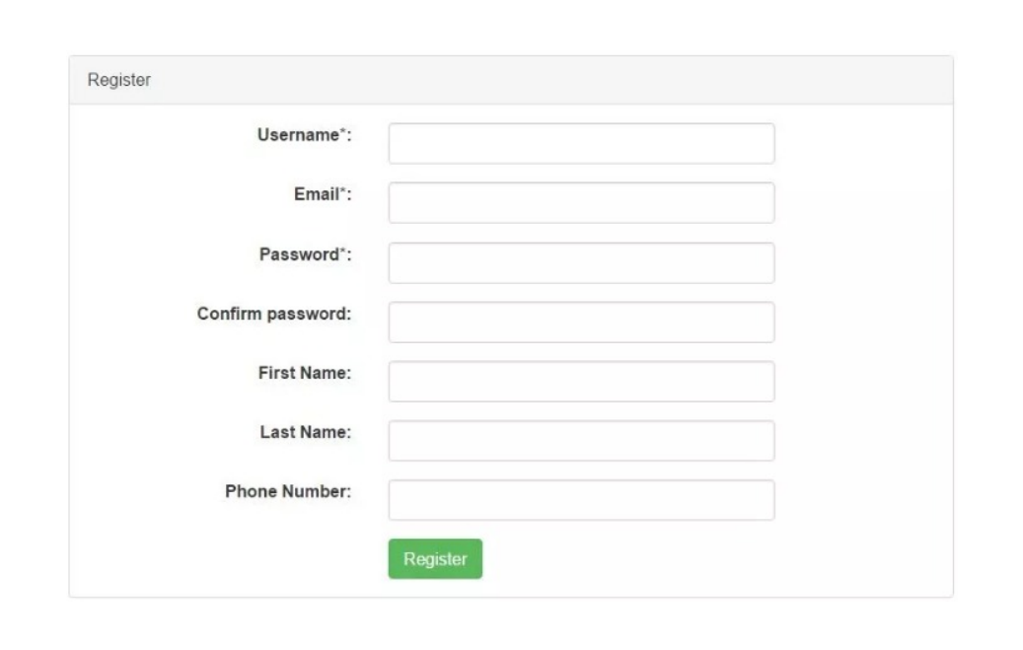

| **Field Name** | **Field Type** | **Description** |
| --- | --- | --- |
| Username* | Text Box | This is for user to input valid username address for register user account |
| Email* | Text Box | This is for user to input valid email address for register user account |
| Password* | Password Box | This is for users who enter their password for register |
| ConfirmPassword | Password Box | This is for users who re-enter their password for register |
| First Name | Text Box | This is for user to input valid first name for register user account |
| Last Name | Text Box | This is for user to input valid last name for register user account |
| Phone Number | Number Box | This is for user to input valid phone number for register user account |
| Register | Button | The user presses the button to register new user account |

##### 

#### c. Functional Description

#### 

| UC ID and Name: | **UC03 – Register User Account** | | | | | |
| --- | --- | --- | --- | --- | --- | --- |
| Created By: | SonNN | | Date Created: | 26/06/2023 | | |
| Primary Actor: | Reviewer | | Secondary Actors: |  | | |
| Trigger: | User clicks Register Account from the Default Sign In screen | | | | | |
| Description: | As a user, I want to be able to register account | | | | | |
| Preconditions: | New account has been created | | | | | |
| Postconditions: | Register account successfully | | | | | |
| Normal Flow: | ***Step*** | ***Step Details*** | | | ***By*** | ***Business Rules*** |
| 1 | Access the Register Account screen | | | User |  |
| 2 | Enter detail account | | | User |  |
| 3 | Click the Save button | | | User |  |
| 4 | Validate account details | | | System |  |
| 5 | Allow user to register account | | | System |  |
| 6 | Created account successfully | | | System |  |
| 7 | Access the Login screen | | | System |  |
| Alternative Flows: | None | | | | | |
| Exceptions: | ***System can’t authenticate***  1. The Error Message screen is shown to the user  2. User cancels register account *=> UC stops, change to Sign In* | | | | | |
| Priority: | Must Have | | | | | |
| Frequency of Use: | None | | | | | |
| Business Rules: | None | | | | | |
| Other Information: | None | | | | | |
| Assumptions: | None | | | | | |

#### d. Business Rules

**`**

## 2. Subject Management UCs

### 2.1 UC04 - View Subject List

#### a. Activity Diagram

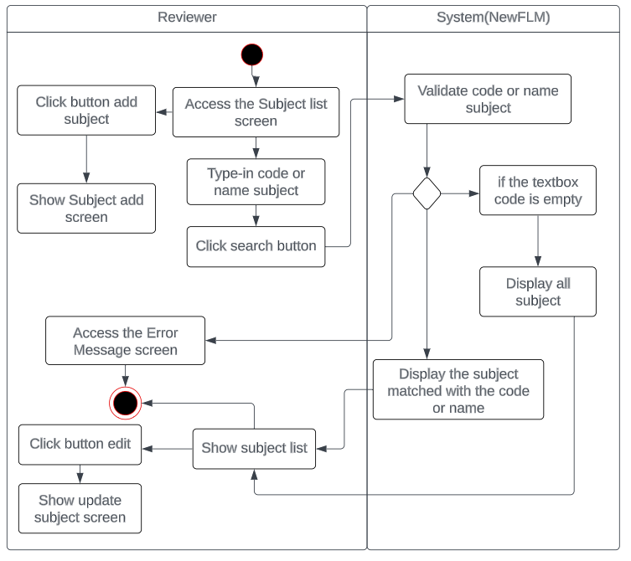

#### b. Prototype/Mockup

##### Subject list screen

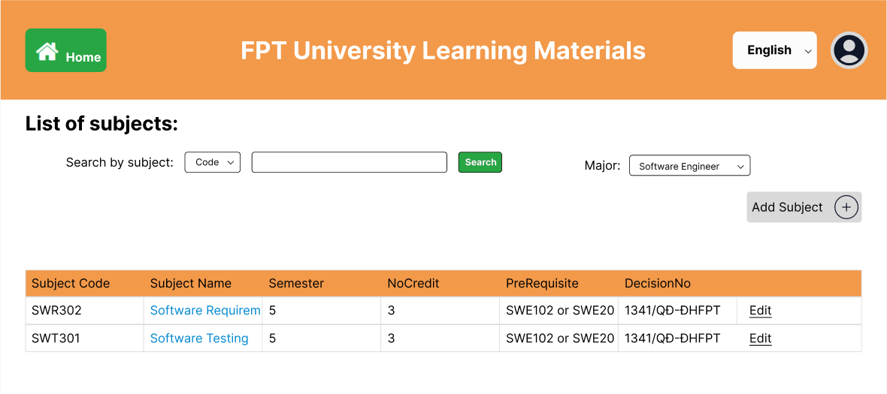

| **Field Name** | **Field Type** | **Description** |
| --- | --- | --- |
| Subject* | Text Box  String (30) | Name or Code of Subject |
| Selection Box | Selection box | Select code or name |
| Search | Button | User clicks to search subject |
| Subject Code | Text | This is code of subject |
| Filter | Combox | Allow user to sort or filter subject by name code ,etc |
| Add Subject | Button | User clicks to add new subject |
| Subject Name | Hyperlink | Allow user to redirect to subject detail page |
| Semester | Combo Box | This is number of semester for subject |
| NoCredit | Combo Box | This is number of NoCredit for subject |
| PreRequisite | Text Box | This is name of subject requisite |
| DecisionNo | Hyperlink | Allow user to redirect to decision detail page |
| Edit | button | Allow user modify curriculum |

#### c. Functional Description

| UC ID and Name: | **UC04 – View Subject List** | | | | | |
| --- | --- | --- | --- | --- | --- | --- |
| Created By: | SonNN | | Date Created: | 26/06/2023 | | |
| Primary Actor: | Reviewer | | Secondary Actors: |  | | |
| Trigger: | User click the “Subject List” | | | | | |
| Description: | The purpose of this use case is to view Subject List in the system | | | | | |
| Preconditions: | Type-in valid code subject | | | | | |
| Postconditions: | Show Subject List | | | | | |
| Normal Flow: | **Step** | **Step Details** | | | **By** | **Business Rules** |
| 1 | Access the Subject List screen | | | User |  |
| 3 | Enter code subject | | | User |  |
| 4 | Click the Search button | | | User |  |
| 5 | Validate code subject details | | | System |  |
| 6 | Allow user to view Subject List | | | System |  |
| 7 | Show Subject List | | | System |  |
| Alternative Flows: | ***If the user does not enter a search keyword***  The system displays all subject.  ***If the user enter a search keyword not match***  Access the error message screen. | | | | | |
| Exceptions: | None | | | | | |
| Priority: | Medium | | | | | |
| Frequency of Use: | None | | | | | |
| Business Rules: | None | | | | | |
| Other Information: | None | | | | | |
| Assumptions: | None | | | | | |

#### d. Business Rules

### 2.2. UC05 –Add New Subject

#### a. Activity Diagram

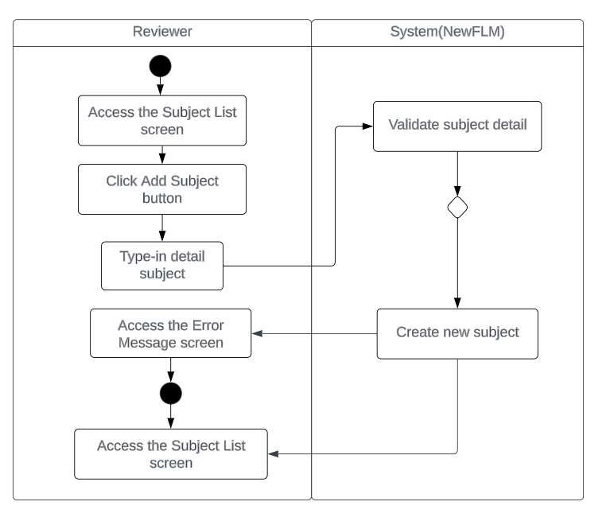

#### b. Prototype/Mockup

##### Subject new screen

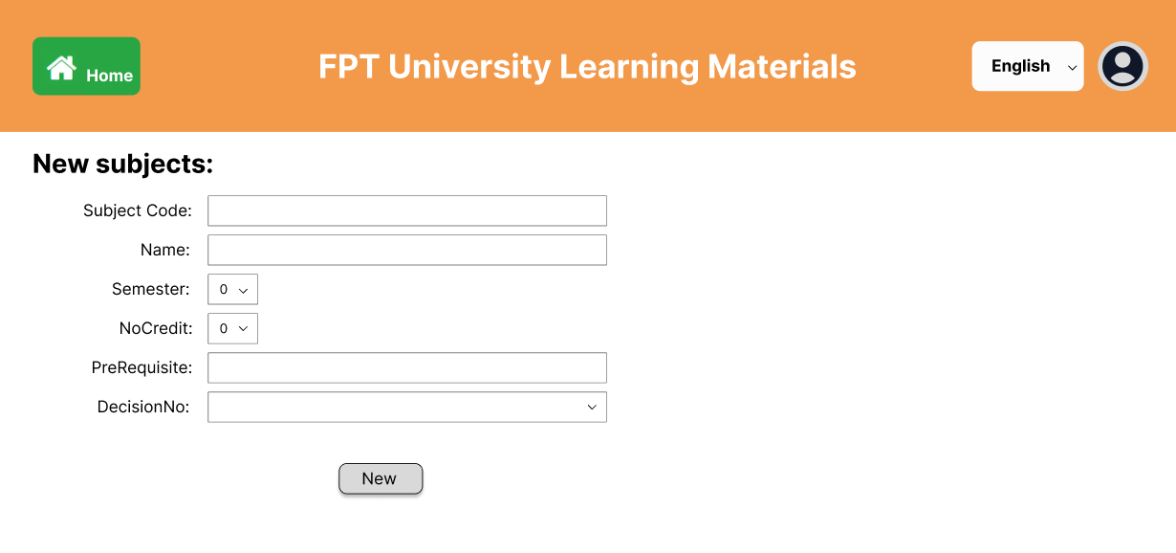

| **Field Name** | **Field Type** | **Description** |
| --- | --- | --- |
| Subject Code | Text Box | This is for user to input code of subject |
| Name | Text Box | This is for user to input name of subject |
| Semester | Combo Box | This is for user to select number of semester for subject |
| NoCredit | Combo Box | This is for user to select number of NoCredit for subject |
| PreRequisite | Text Box | This is for user to input name of subject requisite |
| DecisionNo | Combo box | Allow user choose decision for subject |
| New | Button | The user presses the button to save the information |

##### 

#### c. Functional Description

| UC ID and Name: | **UC05 – Add New Subject** | | | | | |
| --- | --- | --- | --- | --- | --- | --- |
| Created By: | SonNN | | Date Created: | | 26/06/2023 | |
| Primary Actor: | CRDD Staff | | Secondary Actors: | |  | |
| Trigger: | User clicks the “New Subject” link from the Subject List screen, or  User chooses “Add new subject” from Subject Management | | | | | |
| Description: | The purpose of this use case is to create a new subject in the system | | | | | |
| Preconditions: | The user must be logged-in as “CRDD Staff” | | | | | |
| Postconditions: | Add New Subject successfully | | | | | |
| Normal Flow: | ***Step*** | ***Step Details*** | | ***By*** | | ***Business Rules*** |
| 1 | Access the New Subject screen | | User | |  |
| 2 | Type-in subject details | | User | |  |
| 3 | Click the Save button | | User | |  |
| 4 | Validate subject details | | System | | FR1 |
| 5 | Create new subject | | System | |  |
| 6 | Show subject list | | System | |  |
| Alternative Flows: | ***4a. Subject details validation fails***  4a1. System shows the Error Message screen  4a2. User comes back to the step 2 | | | | | |
| Exceptions: | None | | | | | |
| Priority: | High (Medium, Low) | | | | | |
| Frequency of Use: | None | | | | | |
| Business Rules: | None | | | | | |
| Other Information: | None | | | | | |
| Assumptions: | None | | | | | |

#### d. Business Rules

#### 

| **ID** | **Business Rule** | **Business Rule Description** |
| --- | --- | --- |
| FR1 | No duplicates | It must be validated the information has not been added for any existing curriculum |

### 2.3. UC06- Update Subject

#### a. Activity Diagram

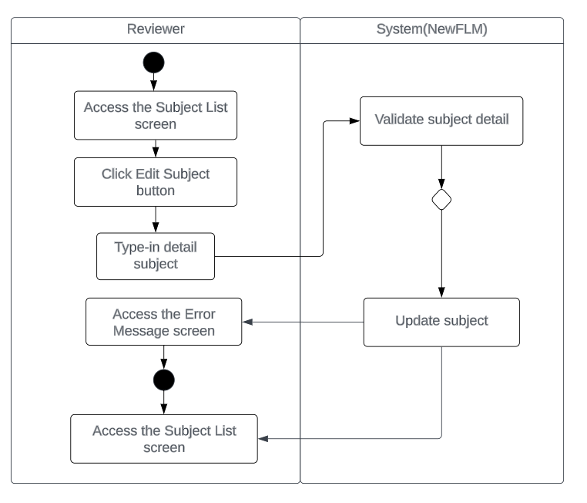

#### b. Prototype/Mockup

##### Subject update screen

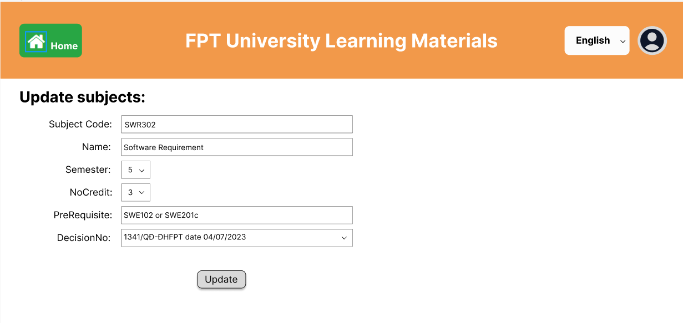

| **Field Name** | **Field Type** | **Description** |
| --- | --- | --- |
| Subject Code | Text Box | This is for user to input code of subject |
| Name | Text Box | This is for user to input name of subject |
| Semester | Combo Box | This is for user to select number of semester for subject |
| NoCredit | Combo Box | This is for user to select number of NoCredit for subject |
| PreRequisite | Text Box | This is for user to input name of subject requisite |
| DecisionNo | Combo box | Allow user choose decision for subject |
| Update | Button | The user presses the button to update the information |

##### 

#### c. Functional Description

| UC ID and Name: | **UC06 – Update Subject** | | | | | |
| --- | --- | --- | --- | --- | --- | --- |
| Created By: | SonNN | | Date Created: | | 26/06/2023 | |
| Primary Actor: | CRDD Staff | | Secondary Actors: | |  | |
| Trigger: | User clicks the “Update Subject” link from the Subject List screen, or  User chooses “Update Subject” from Subject Management | | | | | |
| Description: | The purpose of this use case is to update a subject in the system | | | | | |
| Preconditions: | The user must be logged-in as “CRDD Staff” | | | | | |
| Postconditions: | Update Subject successfully | | | | | |
| Normal Flow: | ***Step*** | ***Step Details*** | | ***By*** | | ***Business Rules*** |
| 1 | Access the Update Subject screen | | User | |  |
| 2 | Type-in subject details | | User | |  |
| 3 | Click the Save button | | User | |  |
| 4 | Validate subject details | | System | |  |
| 5 | Update subject | | System | |  |
| 6 | Show subject list | | System | |  |
| Alternative Flows: | ***4a. User details validation fails***  4a1. System shows the Error Message screen  4a2. User comes back to the step 2 | | | | | |
| Exceptions: | None | | | | | |
| Priority: | High (Medium, Low) | | | | | |
| Frequency of Use: | None | | | | | |
| Business Rules: | None | | | | | |
| Other Information: | None | | | | | |
| Assumptions: | None | | | | | |

#### d. Business Rules

## 3. Curriculum Management UCs

### 3.1. UC07 – View Curriculum List

### a. Activity Diagram

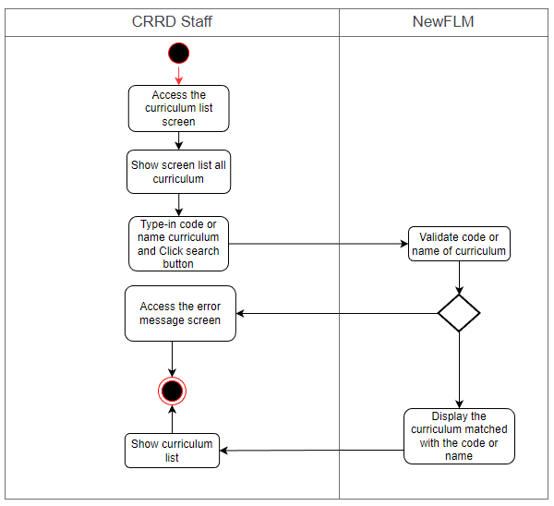

#### b. Prototype/Mockup

##### Curriculum List screen

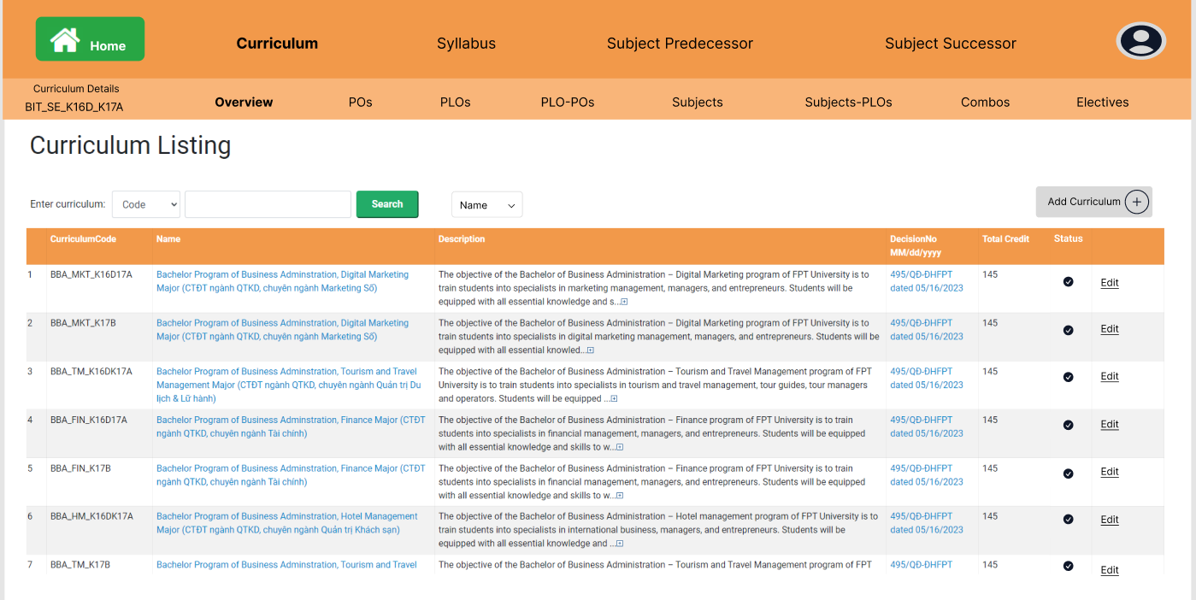

| **Field Name** | **Field Type** | **Description** |
| --- | --- | --- |
| Curriculum* | Text Box  String (30) | Name or Code of Curriculum |
| Selection Box | Selection box | Select code or name |
| Search | Button | User clicks to search curriculum |
| Curriculum Code | Text | This is code of curriculum |
| Filter | Combox | Allow user to sort or filter curriculum by name code ,etc |
| Add Curriculum | Button | User clicks to add new curriculum |
| Name | Hyperlink | Allow user to redirect to curriculum detail page |
| Description | Text | This is information about curriculum |
| DecisionNo | Hyperlink | Allow user to redirect to decision detail page |
| Status | Checkbox | Let the user know if this curriculum is still in use |
| Total Credit | Text | This is credit number of curriculum |
| Edit | button | Allow user modify curriculum |

#### c. Functional Description

| UC ID and Name: | **UC07 – View Curriculum List** | | | | | |
| --- | --- | --- | --- | --- | --- | --- |
| Created By: | TrungVK | | Date Created: | | 26/06/2023 | |
| Primary Actor: | CRDD Staff | | Secondary Actors: | |  | |
| Trigger: | User clicks the “Curriculum” menu from the NavBar then click overview from sub-header | | | | | |
| Description: | The function allows the user to view the curriculum list. | | | | | |
| Preconditions: | The user must be connection internet, and login as “CRDD Staff | | | | | |
| Postconditions: | * The user successfully views the curriculum information. * The user can access and refer to the curriculum information as needed. * The user can modify curriculum | | | | | |
| Normal Flow: | ***Step*** | ***Step Details*** | | ***By*** | | ***Business Rules*** |
| 1 | Access the curriculum list screen | | User | |  |
| 2 | Type-in code or name curriculum | | User | |  |
| 3 | Click search button | | User | |  |
| 4 | Validate code or name of curriculum | | System | |  |
| 5 | Display the curriculum matched with the code or name | | System | |  |
| 6 | Show curriculum list | | User | |  |
| Alternative Flows: | ***4a. If the user does not enter a search keyword***  4a.1. The system displays all curriculum.  ***4b. If the user enter a search keyword not match***  4b.1. Access the error message screen. | | | | | |
| Exceptions: | If the web platform experiences technical issues or downtime, the system displays appropriate error messages and allows the user to try again later | | | | | |
| Priority: | High | | | | | |
| Frequency of Use: | Arable, depending on the user's need to access the curriculum | | | | | |
| Business Rules: | BR1 | | | | | |
| Other Information: | N/A | | | | | |
| Assumptions: | The system ensures the privacy and security of user data and course information. | | | | | |

#### d. Business Rules

| **ID** | **Business Rule** | **Business Rule Description** |
| --- | --- | --- |
| BR1 | Connection | Actor’s internet connection is available |

### 3.2. UC08 - Add New Curriculum

#### a. Activity Diagram

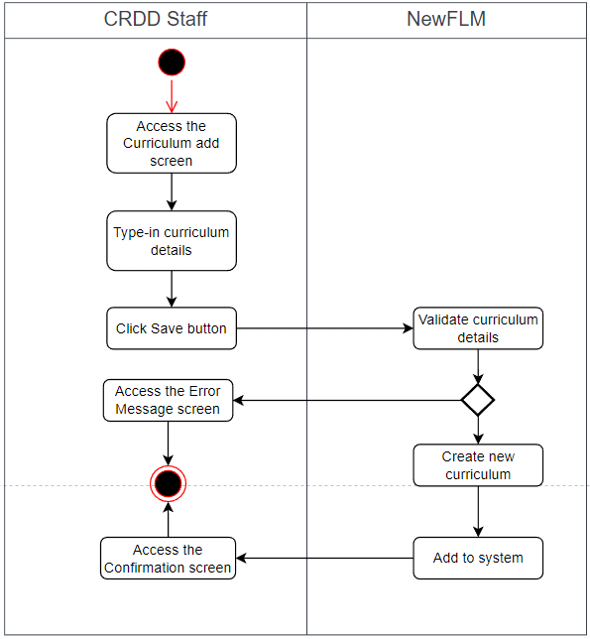

#### b. Prototype/Mockup

##### Add New Curriculum screen

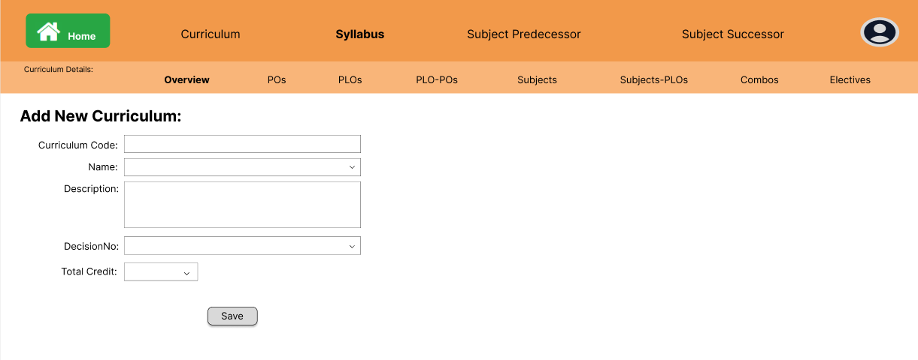

| **Field Name** | **Field Type** | **Description** |
| --- | --- | --- |
| Curriculum Code | Text Box | This is for user to input code of curriculum |
| Name | Text Box | This is for user to input name of curriculum |
| Description | Text Box | This is for user to input more information about curriculum |
| DecisionNo | Combo Box | This is for user to select decision for curriculum |
| Total Credit | Text Box | This is for user to input total credit for curriculum |
| Save | Button | The user presses the button to save the information |

#### c. Functional Description

| UC ID and Name: | **UC08 – Add New Curriculum** | | | | | |
| --- | --- | --- | --- | --- | --- | --- |
| Created By: | TrungVK | | Date Created: | | 26/06/2023 | |
| Primary Actor: | CRDD Staff | | Secondary Actors: | |  | |
| Trigger: | User clicks the “Curriculum” button from Navbar then click “ Add Curriculum” button | | | | | |
| Description: | The purpose of this use case is to create a new curriculum in the system | | | | | |
| Preconditions: | The user must be logged-in as “CRDD Staff” | | | | | |
| Postconditions: | A new curriculum is created in the system  The curriculum created is edited by CRDD Staff and CRDD Designer | | | | | |
| Normal Flow: | ***Step*** | ***Step Details*** | | ***By*** | | ***Business Rules*** |
| 1 | Access the Curriculum add screen | | User | |  |
| 2 | Type-in curriculum details | | User | |  |
| 3 | Click the Save button | | User | |  |
| 4 | Validate curriculum details | | System | | FR1 |
| 5 | Create new curriculum | | System | |  |
| 6 | Add to system | | System | |  |
| 7 | Access the Confirmation screen | | User | |  |
| Alternative Flows: | ***4a. Curriculum name validation fails***  4a1. System shows the Error Message screen  4a2. User comes back to the step 2 | | | | | |
| Exceptions: | None | | | | | |
| Priority: | Medium | | | | | |
| Frequency of Use: | Depends on the frequency of changes in the system | | | | | |
| Business Rules: | N/A | | | | | |
| Other Information: |  | | | | | |
| Assumptions: |  | | | | | |

#### d. Business Rules

| **ID** | **Business Rule** | **Business Rule Description** |
| --- | --- | --- |
| FR1 | No duplicates | It must be validated the information has not been added for any existing curriculum |

### 3.3. UC09- Update Curriculum

#### a. Activity Diagram

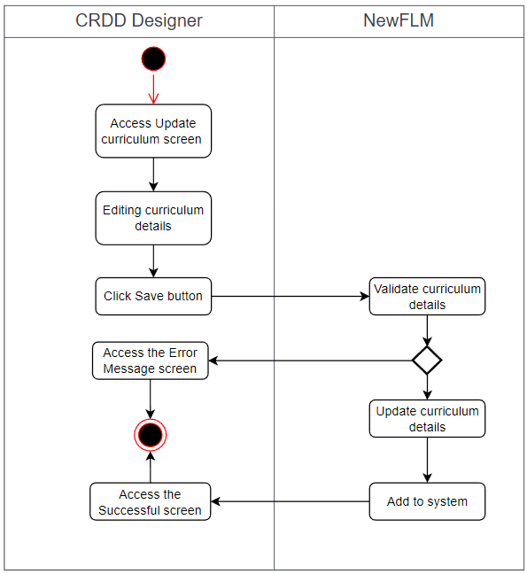

#### b. Prototype/Mockup

##### Update Curriculum Screen

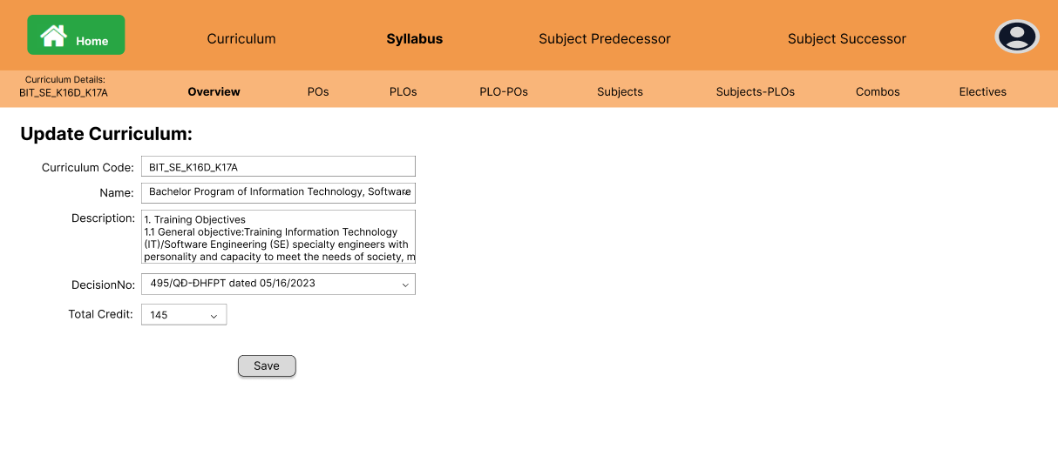

| **Field Name** | **Field Type** | **Description** |
| --- | --- | --- |
| Curriculum Code | Text Box | This is for user to input code of curriculum |
| Name | Text Box | This is for user to input name of curriculum |
| Description | Text Box | This is for user to input more information about curriculum |
| Decision | Combo Box | This is for user to select decision for curriculum |
| Total Credit | Text Box | This is for user to input total credit for curriculum |
| Save | Button | The user presses the button to save the information |

#### 

#### c. Functional Description

#### 

| UC ID and Name: | **UC09 – Update Curriculum** | | | | | |
| --- | --- | --- | --- | --- | --- | --- |
| Created By: | TrungVK | | Date Created: | | 26/06/2023 | |
| Primary Actor: | CRDD Staff | | Secondary Actors: | | CRDD Head | |
| Trigger: | User clicks the “View curriculum” button from Navbar  Click “ Search” button to find curriculum want update  Click “Edit” button to update curriculum | | | | | |
| Description: | The purpose of this use case is to update a curriculum | | | | | |
| Preconditions: | The user must be logged-in as “CRDD Head or CRDD Staff ” | | | | | |
| Postconditions: | The curriculum is updated in the system  The curriculum is edited by CRDD Staff and CRDD Designer. | | | | | |
| Normal Flow: | ***Step*** | ***Step Details*** | | ***By*** | | ***Business Rules*** |
| 1 | Access Update Curriculum screen | | User | |  |
| 2 | Editing curriculum details | | User | |  |
| 3 | Click the Save button | | User | |  |
| 4 | Validate curriculum details | | System | |  |
| 5 | Updated curriculum | | System | |  |
| 6 | Add to system | | System | |  |
| 7 | Access the successful screen | | User | |  |
| Alternative Flows: | ***a. Curriculum details validation fails***  a1. System shows the Error Message screen  a2. User comes back to the step 2 | | | | | |
| Exceptions: | None | | | | | |
| Priority: | High | | | | | |
| Frequency of Use: | Depends on the frequency of changes in the system | | | | | |
| Business Rules: |  | | | | | |
| Other Information: |  | | | | | |
| Assumptions: |  | | | | | |

## 4. Syllabus Management UCs

### 4.1. UC010 - View Syllabus List

#### a. Activity Diagram

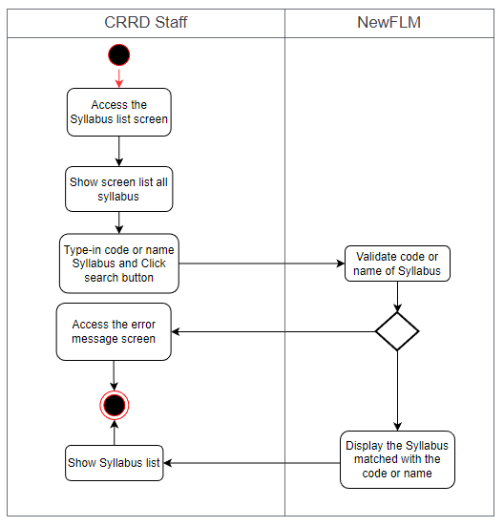

#### b. Prototype/Mockup

##### View Syllabus List screen

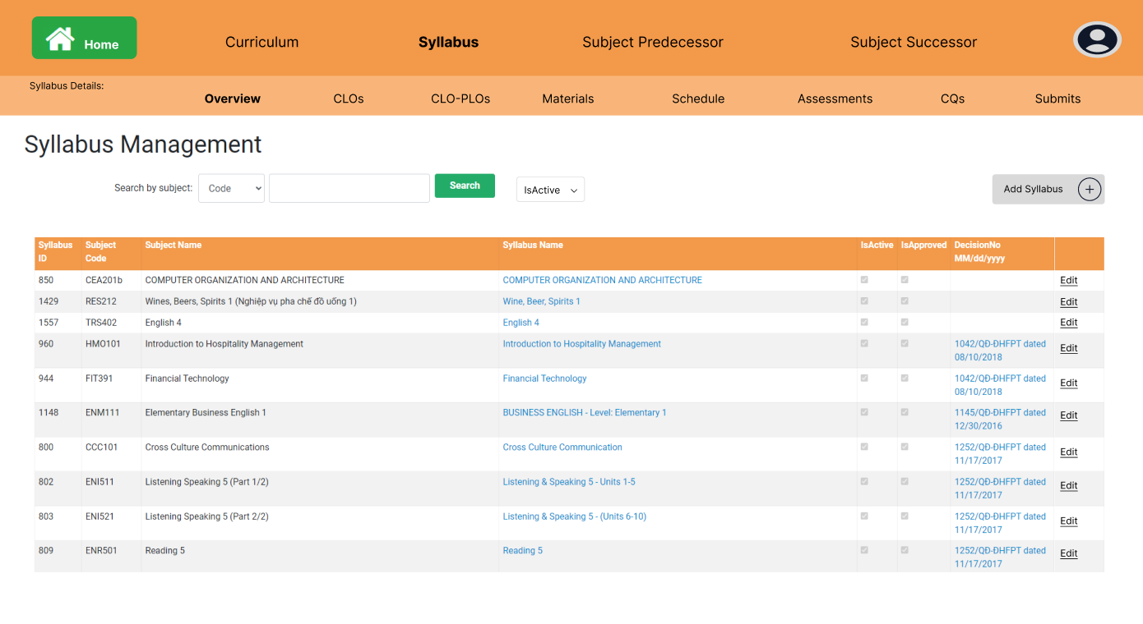

| **Field Name** | **Field Type** | **Description** |
| --- | --- | --- |
| Search by subject | Text Box  String (30) | Name or Code of subject |
| Selection Box | Selection box | Select code or name |
| Search | Button | User clicks to search curriculum |
| Syllabus ID | Text | This is id of syllabus |
| Filter | Combox | Allow user to sort or filter syllabus by name or code ,etc |
| Add Syllabus | Button | User clicks to add new curriculum |
| Syllabus Name | Hyperlink | Allow user to redirect to curriculum detail page |
| Subject Name | Text | This is name of subject |
| DecisionNo | Hyperlink | Allow user to redirect to decision detail page |
| IsActive | Checkbox | Let the user know if this curriculum is still in use |
| IsApprove | Checkbox | Let the user know if this curriculum is still in use |
| Edit | Button | Allow user modify curriculum |

#### c. Functional Description

#### 

| UC ID and Name: | **UC010 – View Syllabus List** | | | | | |
| --- | --- | --- | --- | --- | --- | --- |
| Created By: | TrungVK | | Date Created: | | 26/06/2023 | |
| Primary Actor: | CRDD Staff | | Secondary Actors: | |  | |
| Trigger: | User clicks the “Syllabus” menu from the NavBar then click overview from sub-header | | | | | |
| Description: | The function allows the user to view the syllabus list. | | | | | |
| Preconditions: | The user must be connection internet | | | | | |
| Postconditions: | * The user successfully views the syllabus information. * The user can access and refer to the syllabus information as needed. | | | | | |
| Normal Flow: | ***Step*** | ***Step Details*** | | ***By*** | | ***Business Rules*** |
| 1 | Access the Syllabus list screen | | User | |  |
| 2 | Type-in code or name syllabus | | User | |  |
| 3 | Click search button | | User | |  |
| 4 | Validate code or name of syllabus | | System | |  |
| 5 | Display the syllabus matched with the code or name | | System | |  |
| 6 | Show curriculum list | | User | |  |
| Alternative Flows: | ***4a. If the user does not enter a search keyword***  4a.1. The system displays all syllabus.  ***4b. If the user enter a search keyword not match***  4b.1. Access the error message screen. | | | | | |
| Exceptions: | If the web platform experiences technical issues or downtime, the system displays appropriate error messages and allows the user to try again later | | | | | |
| Priority: | High | | | | | |
| Frequency of Use: | Arable, depending on the user's need to access the curriculum | | | | | |
| Business Rules: | BR1 | | | | | |
| Other Information: | N/A | | | | | |
| Assumptions: |  | | | | | |

#### d. Business Rules

#### 

| **ID** | **Business Rule** | **Business Rule Description** |
| --- | --- | --- |
| BR1 | Connection | Actor’s internet connection is available |

### 4.2 UC011 - Add New Syllabus

#### a. Activity Diagram

#### 

#### 

#### 

#### 

#### 

#### 

#### 

#### 

#### 

#### b. Prototype/Mockup

##### Syllabus Add New screen

| **Field Name** | **Field Type** | **Description** |
| --- | --- | --- |
| Syllabus ID | Text Box  String (30) | This is ID of syllabus |
| Subject | Combo box | This allow user choose subject |
| Syllabus Name | TextBox | Allow user to input name of syllabus |
| DecisionNo | Combo box | Allow user choose decision for syllabus |
| IsActive | Checkbox | Let the user know if this curriculum is still in use |
| IsApprove | Checkbox | Let the user know if this curriculum is still in use |
| Save | Button | Allow user to save syllabus details |

#### c. Functional Description

#### 

| UC ID and Name: | **UC11 – Add New Curriculum** | | | | | |
| --- | --- | --- | --- | --- | --- | --- |
| Created By: | TrungVK | | Date Created: | | 26/06/2023 | |
| Primary Actor: | CRDD Staff | | Secondary Actors: | |  | |
| Trigger: | User clicks the “Syllabus” from NavBar then click “ Add Syllabus” button | | | | | |
| Description: | The purpose of this use case is to create a new curriculum in the system | | | | | |
| Preconditions: | The user must be logged-in as “CRDD Staff” | | | | | |
| Postconditions: | A new syllabus is created in the system  The syllabus created is edited by CRDD Staff and CRDD Designer | | | | | |
| Normal Flow: | ***Step*** | ***Step Details*** | | ***By*** | | ***Business Rules*** |
| 1 | Access the Syllabus add screen | | User | |  |
| 2 | Type-in Syllabus details | | User | |  |
| 3 | Click the Save button | | User | |  |
| 4 | Validate Syllabus details | | System | | FR1 |
| 5 | Create new syllabus | | System | |  |
| 6 | Add to system | | System | |  |
| 7 | Access the Confirmation screen | | User | |  |
| Alternative Flows: | ***4a. Syllabus name validation fails***  4a1. System shows the Error Message screen  4a2. User comes back to the step 2 | | | | | |
| Exceptions: | None | | | | | |
| Priority: | Medium | | | | | |
| Frequency of Use: | Depends on the frequency of changes in the system | | | | | |
| Business Rules: | N/A | | | | | |
| Other Information: |  | | | | | |
| Assumptions: |  | | | | | |

#### d. Business Rules

| **ID** | **Business Rule** | **Business Rule Description** |
| --- | --- | --- |
| FR1 | No duplicates | It must be validated the information has not been added for any existing syllabus |

### 4.3 UC012 - Update Syllabus

#### a. Activity Diagram

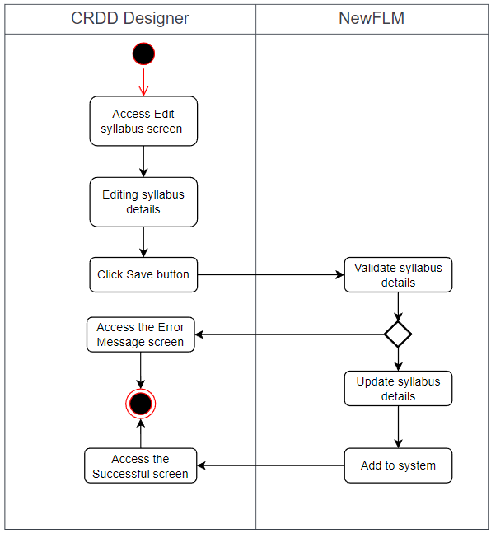

#### b. Prototype/Mockup

##### Syllabus Update screen

##### 

| **Field Name** | **Field Type** | **Description** |
| --- | --- | --- |
| Syllabus ID | Text Box  String (30) | This is ID of syllabus |
| Subject | Combo box | This allow user choose subject |
| Syllabus Name | TextBox | Allow user to input name of syllabus |
| DecisionNo | Combo box | Allow user choose decision for syllabus |
| IsActive | Checkbox | Let the user know if this curriculum is still in use |
| IsApprove | Checkbox | Let the user know if this curriculum is still in use |
| Save | Button | Allow user to save syllabus details |

#### c. Functional Description

#### 

| UC ID and Name: | **UC12 – Update Syllabus** | | | | | |
| --- | --- | --- | --- | --- | --- | --- |
| Created By: | TrungVK | | Date Created: | | 26/06/2023 | |
| Primary Actor: | CRDD Designer | | Secondary Actors: | | CRDD Head | |
| Trigger: | User clicks the “Syllabus” button from NavBar  Click “ Search” button to find syllabus want update  Click “Edit” button to update syllabus | | | | | |
| Description: | The purpose of this use case is to update a curriculum | | | | | |
| Preconditions: | The user must be logged-in as “CRDD Designer ” | | | | | |
| Postconditions: | The curriculum is updated in the system  The curriculum is edited by CRDD Designer. | | | | | |
| Normal Flow: | ***Step*** | ***Step Details*** | | ***By*** | | ***Business Rules*** |
| 1 | Access the Edit Syllabus screen | | User | |  |
| 2 | Editing Syllabus information | | User | |  |
| 3 | Click the Save button | | User | |  |
| 4 | Validate Syllabus details | | System | |  |
| 5 | Updated Syllabus | | System | |  |
| 6 | Notification of successful | | System | |  |
| 7 | Back to the Manage Syllabus screen | | System | |  |
| Alternative Flows: | ***2a. Curriculum details validation fails***  2a1. System shows the Error Message screen  2a2. User comes back to the step 2 | | | | | |
| Exceptions: | None | | | | | |
| Priority: | High | | | | | |
| Frequency of Use: | Depends on the frequency of changes in the system | | | | | |
| Business Rules: |  | | | | | |
| Other Information: |  | | | | | |
| Assumptions: |  | | | | | |

#### d. Business Rules

#### 

| **ID** | **Business Rule** | **Business Rule Description** |
| --- | --- | --- |
|  |  |  |

## 5. Syllabus CLO Management UCs

### 5.1. UC013 - View Syllabus CLO List

#### a. Activity Diagram

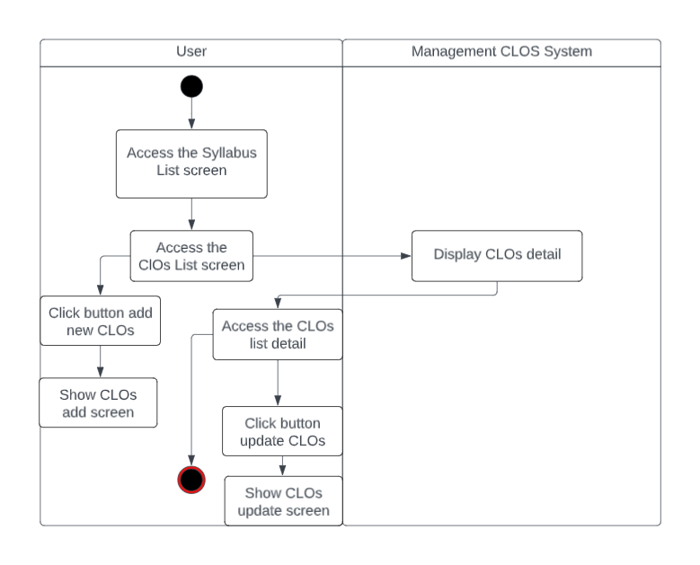

#### b. Prototype/Mockup

##### View CLo List screen

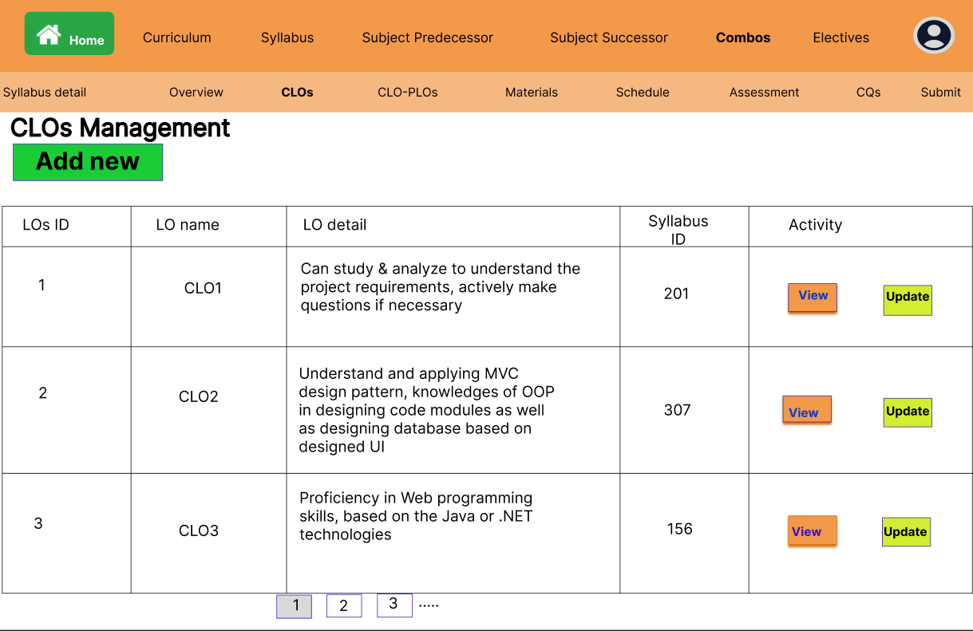

| **Field Name** | **Field Type** | **Description** |
| --- | --- | --- |
| LOs ID | Value | Displays the ID addresses of each LO |
| LOs name | Value | Displays the Name of each LO |
| LOs detail | Value | Displays the Detail of each LO |
| Syllabus ID | Value | Displays the ID addresses of each syllabus according to the CLOs |
| Add new | Button | User clicks to add new CLOs |
| Update | button | Allow user modify CLOs |
| View | button | Display all info of ClOs |

#### c. Functional Description

#### 

| UC ID and Name: | **UC013 – View CLO List** | | | | | |
| --- | --- | --- | --- | --- | --- | --- |
| Created By: | DungLm | | Date Created: | | 26/06/2023 | |
| Primary Actor: | User | | Secondary actor | | Management CLOs System | |
| Trigger: | Click on the “view CLOs detail” button in syllabus list | | | | | |
| Description: | Allow users access to view the CLO. For roles like teacher and student, to view Clo, but with management roles, you will be able to view, edit, delete, and manage easily. | | | | | |
| Preconditions: | Null | | | | | |
| Postconditions: | The user successfully views the CLO list and CLO information. | | | | | |
| Normal Flow: | ***Step*** | ***Step Details*** | | ***By*** | |  |
| 1 | Users login and can see the list of syllabus | | User | |  |
| 2 | Users click on button to view syllabus detail | | User | |  |
| 3 | Users click on the button to view CLO detail. | | User | |  |
| Alternative Flows: | *If the user does not enter a search keyword,*the system displays the entire syllabus. | | | | | |
| Exceptions: | If the web platform experiences technical issues or downtime, the system displays appropriate error messages and allows the user to try again later | | | | | |
| Priority: | High | | | | | |
| Frequency of Use: | Arable, depending on the user's need to access the curriculum | | | | | |
| Business Rules: | BR1 | | | | | |
| Other Information: | N/A | | | | | |
| Assumptions: | The system ensures the privacy and security of user data and course information. | | | | | |

#### d. Business Rules

#### 

| **ID** | **Business Rule** | **Business Rule Description** |
| --- | --- | --- |
| BR1 | Connection | Actor’s internet connection is available |

### 5.2 UC014 - Update Syllabus CLO

#### a. Activity Diagram

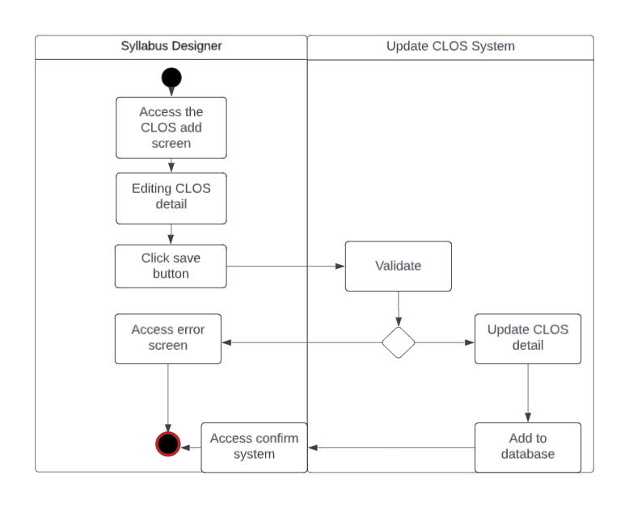

#### b. Prototype/Mockup

##### Update CLOs screen

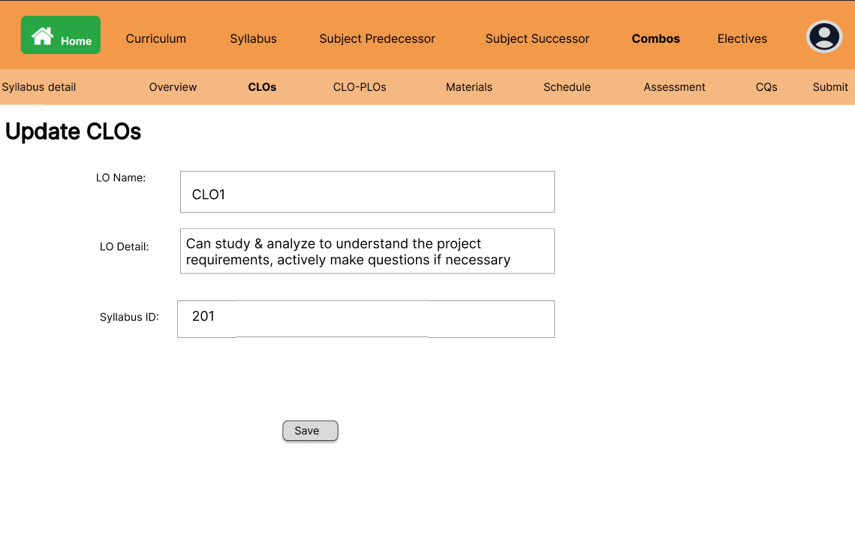

| **Field Name** | **Field Type** | **Description** |
| --- | --- | --- |
| LOs name | Value | Displays the Name of each LO |
| LOs detail | Value | Displays the Detail of each LO |
| Syllabus ID | Value | Displays the ID addresses of each syllabus according to the CLOs |

#### c. Functional Description

#### 

| UC ID and Name: | **UC014 – Update Syllabus CLO** | | | | |
| --- | --- | --- | --- | --- | --- |
| Created By: | DungLm | | Date Created: | | 26/06/2023 |
| Primary Actor: | CRDD Staff,Syllabus Designer | | Secondary actor | | Update CLOs system |
| Trigger: | Click on the “update CLO” button | | | | |
| Description: | Allow CRDD Staff,Syllabus Designer access to modify and update CLO | | | | |
| Preconditions: | The user must be logged-in as “Syllabus Designer” or “CRDD Staff” | | | | |
| Postconditions: | The CLOis updated in the system  The CLO created is edited by CRDD Staff | | | | |
| Normal Flow: | ***Step*** | ***Step Details*** | |  | |
| 1 | Users login with CRDD Staff or Syllabus Designer role | |  | |
| 2 | Users click on button to view syllabus detail | |  | |
| 3 | Users click on the button to view CLO detail. | |  | |
| 4 | Users modify or edit CLO and click “save” button to save information | |  | |
| Alternative Flows: | *If the user does not enter a search keyword,*the system displays the entire syllabus.  If the staff click save, new CLO will be save | | | | |
| Exceptions: | If the web platform experiences technical issues or downtime, the system displays appropriate error messages and allows the user to try again later | | | | |
| Priority: | High | | | | |
| Frequency of Use: | Arable, depending on the user's need to access the syllabus | | | | |
| Business Rules: | BR1 | | | | |
| Other Information: | N/A | | | | |
| Assumptions: | The system ensures the privacy and security of user data and course information. | | | | |

#### d. Business Rules

#### 

| **ID** | **Business Rule** | **Business Rule Description** |
| --- | --- | --- |
| BR1 | Connection | Actor’s internet connection is available |

### 5.3 UC015 - Add New Syllabus CLO

#### a. Activity Diagram

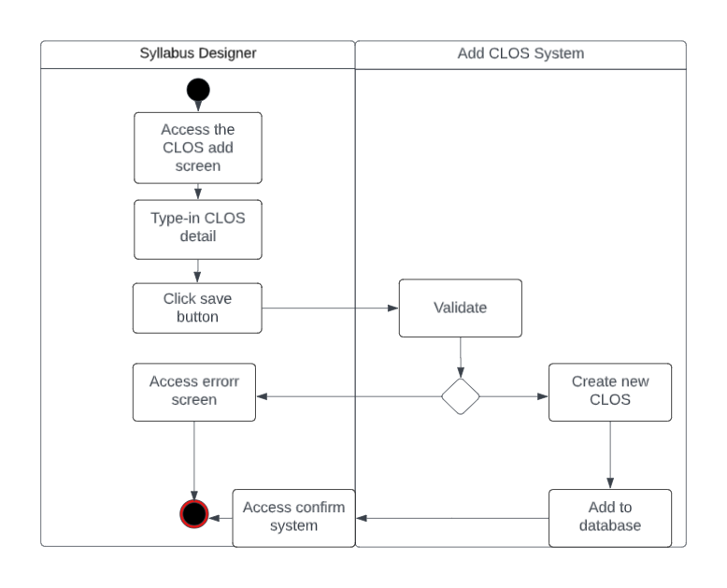

#### b. Prototype/Mockup

##### New CLOs screen

| **Field Name** | **Field Type** | **Description** |
| --- | --- | --- |
| LOs name | Value | Input for the Name of each LO |
| LOs detail | Value | Input for the Detail of each LO |
| Syllabus ID | Value | Input for the ID addresses of each syllabus according to the CLOs |

#### c. Functional Description

#### 

| UC ID and Name: | **UC01 – Add new syllabus CLO** | | | | |
| --- | --- | --- | --- | --- | --- |
| Created By: | DungLm | | Date Created: | | 26/06/2023 |
| Primary Actor: | CRDD Staff,Syllabus Designer | | Secondary actor | | Add CLOS System |
| Trigger: | Click on the “add CLOs” button | | | | |
| Description: | Allow CRDD Staff, Syllabus Designer access to add new CLO | | | | |
| Preconditions: | The user must be logged-in as “Syllabus Designer” or “CRDD Staff” | | | | |
| Postconditions: | A new curriculum is created in the system  The curriculum created is edited by Syllabus Designer | | | | |
| Normal Flow: | ***Step*** | ***Step Details*** | | ***By*** | |
| 1 | Users click on button to view syllabus detail | | User | |
| 2 | Users click on the button to view CLos details. | | User | |
| 3 | Users Click “add new” button | | User | |
| 4 | User input | | User | |
| 5 | Users add new CLos and click “add” button to save information | | User | |
| Alternative Flows: | *If the user does not enter a search keyword,*the system displays the entire syllabus.  If the staff click add, new CLO will be save | | | | |
| Exceptions: | If the web platform experiences technical issues or downtime, the system displays appropriate error messages and allows the user to try again later | | | | |
| Priority: | High | | | | |
| Frequency of Use: | Arable, depending on the user's need to access the curriculum | | | | |
| Business Rules: | BR1 | | | | |
| Other Information: | N/A | | | | |
| Assumptions: | The system ensures the privacy and security of user data and course information. | | | | |

#### d. Business Rules

#### 

| **ID** | **Business Rule** | **Business Rule Description** |
| --- | --- | --- |
| BR1 | Connection | Actor’s internet connection is available |

## 6. Syllabus Assessment Management UCs

### 6.1. UC016 - View Assessment Syllabus List

#### a. Activity Diagram

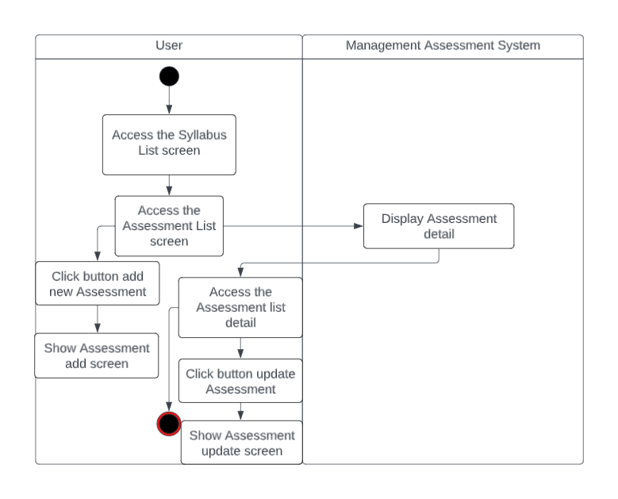

#### b. Prototype/Mockup

##### View Assessment list screen

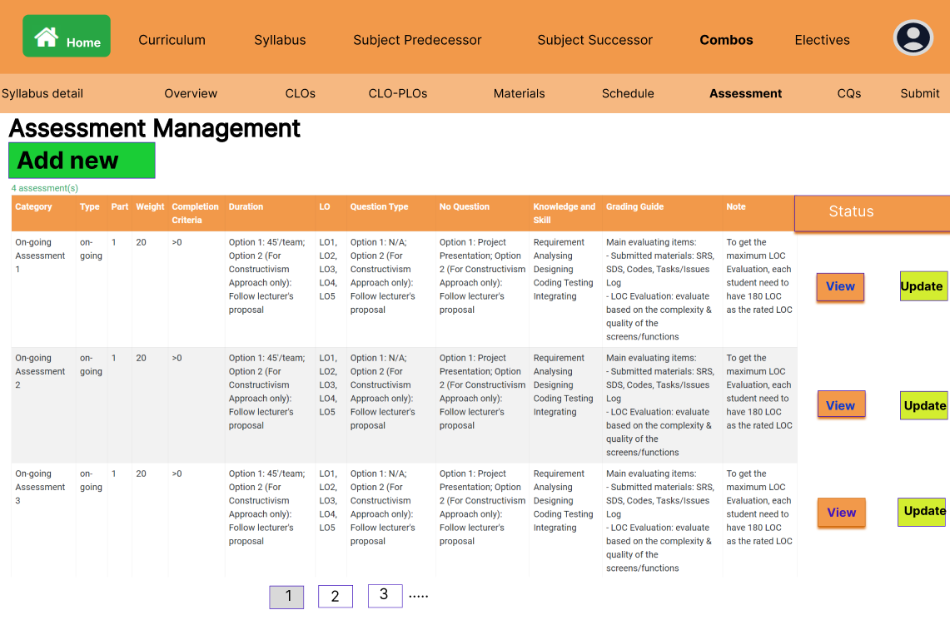

| **Field Name** | **Field Type** | **Description** |
| --- | --- | --- |
| Category | Value | Displays value |
| Type | Value | Displays value |
| Part | Value | Displays value |
| Weight | Value | Displays value |
| Completion Criteria | Value | Displays value |
| Duration | Value | Displays value |
| LO | Value | Displays value |
| Question Type | Value | Displays value |
| No Question | Value | Displays value |
| Knowledge and Skill | Value | Displays value |
| Duration | Value | Displays value |
| Grading Guide | Value | Displays value |
| Add new | Button | User clicks to add new assessment |
| Update | button | Allow user modify assessment |
| View | button | Display all info of assessment |

#### 

#### c. Functional Description

#### 

| UC ID and Name: | **UC016 – View assessment syllabus list** | | | | |
| --- | --- | --- | --- | --- | --- |
| Created By: | DungLm | | Date Created: | | 26/06/2023 |
| Primary Actor: | Users | | Secondary actor | | View Assessment system |
| Trigger: | Click on the “view Assessment” button | | | | |
| Description: | Allow users access to view the Assessment. For roles like teacher and student, to view assessment, but with management roles, you will be able to view, edit, delete, and manage easily. | | | | |
| Preconditions: | Users must login to system | | | | |
| Postconditions: | The user successfully views the assessment list | | | | |
| Normal Flow: | ***Step*** | ***Step Details*** | |  | |
| 1 | Users login and can see the list of syllabus | |  | |
| 2 | Users click on button to view syllabus detail | |  | |
| 3 | Users click on the button to view assessment syllabus detail. | |  | |
| Alternative Flows: | *If the user does not enter a search keyword,*the system displays the entire syllabus. | | | | |
| Exceptions: | If the web platform experiences technical issues or downtime, the system displays appropriate error messages and allows the user to try again later | | | | |
| Priority: | High | | | | |
| Frequency of Use: | Arable, depending on the user's need to access the curriculum | | | | |
| Business Rules: | BR1 | | | | |
| Other Information: | N/A | | | | |
| Assumptions: | The system ensures the privacy and security of user data and course information. | | | | |

#### d. Business Rules

| **ID** | **Business Rule** | **Business Rule Description** |
| --- | --- | --- |
| BR1 | Connection | Actor’s internet connection is available |

### 6.2 UC017 - Update Assessment Syllabus

#### a. Activity Diagram

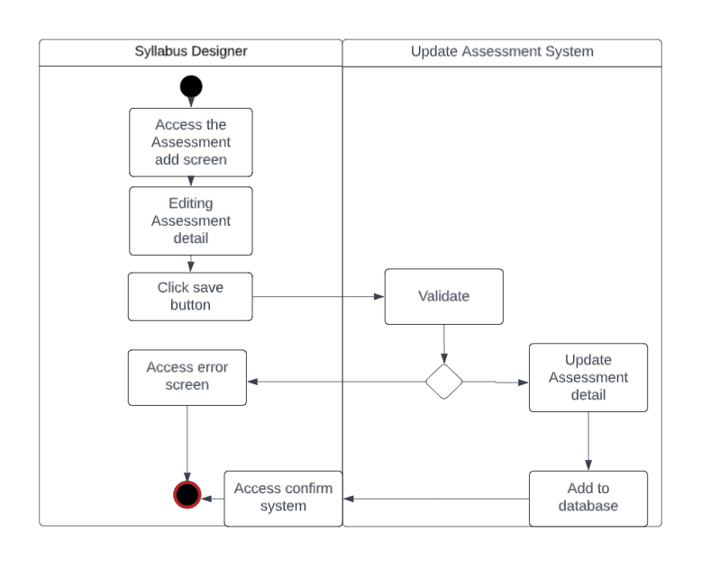

#### b. Prototype/Mockup

##### Update Assessment syllabus screen

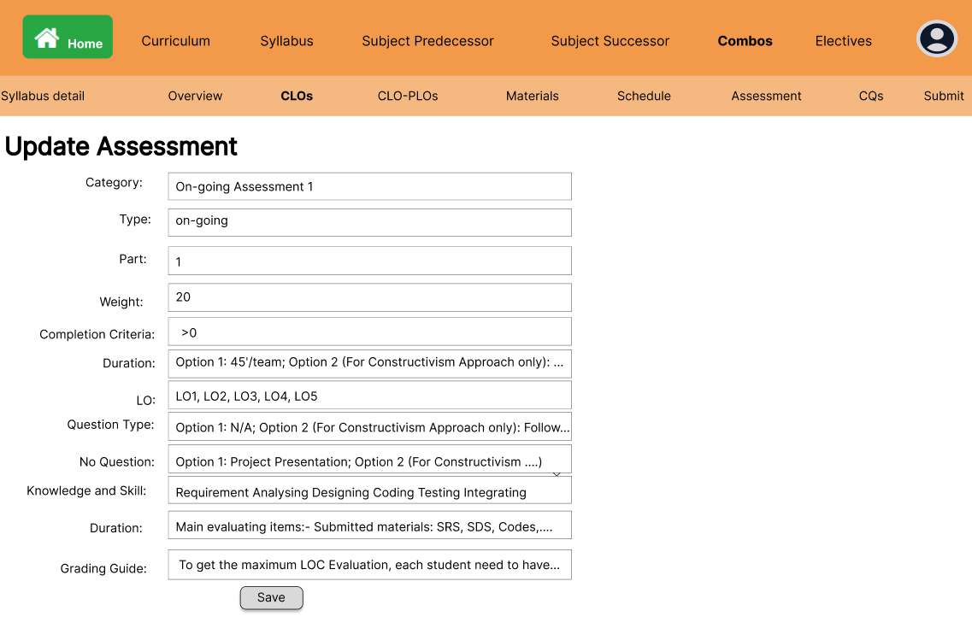

| **Field Name** | **Field Type** | **Description** |
| --- | --- | --- |
| Category | Value | Displays value |
| Type | Value | Displays value |
| Part | Value | Displays value |
| Weight | Value | Displays value |
| Completion Criteria | Value | Displays value |
| Duration | Value | Displays value |
| LO | Value | Displays value |
| Question Type | Value | Displays value |
| No Question | Value | Displays value |
| Knowledge and Skill | Value | Displays value |
| Duration | Value | Displays value |
| Grading Guide | Value | Displays value |
| Save | Button | User clicks to add new assessment |

#### c. Functional Description

#### 

| UC ID and Name: | **UC017 – Update Assessment Syllabus** | | | | |
| --- | --- | --- | --- | --- | --- |
| Created By: | DungLm | | Date Created: | | 26/06/2023 |
| Primary Actor: | CRDD Staff,Syllabus Designer | | Secondary actor | | Update Assessment System |
| Trigger: | Click on the “update assessments” button | | | | |
| Description: | Allow CRDD Staff, CRDD Head access to modify and update assessments | | | | |
| Preconditions: | The user must be logged-in as “Syllabus Designer” or “CRDD Staff” | | | | |
| Postconditions: | The assessments is updated in the system  The assessments created is edited by Syllabus Designer | | | | |
| Normal Flow: | ***Step*** | ***Step Details*** | |  | |
| 1 | Users login with CRDD Staff or Syllabus Designer role | |  | |
| 2 | Users click on button to view syllabus detail | |  | |
| 3 | Users click on the button to view assessments in detail. | |  | |
| 4 | Users modify or edit assessments and click “save” button to save information | |  | |
| Alternative Flows: | *If the user does not enter a search keyword,*the system displays the entire syllabus.  If the staff click save, new assessments will be save | | | | |
| Exceptions: | If the web platform experiences technical issues or downtime, the system displays appropriate error messages and allows the user to try again later | | | | |
| Priority: | High | | | | |
| Frequency of Use: | Arable, depending on the user's need to access the curriculum | | | | |
| Business Rules: | BR1 | | | | |
| Other Information: | N/A | | | | |
| Assumptions: | The system ensures the privacy and security of user data and course information. | | | | |

#### d. Business Rules

#### 

| **ID** | **Business Rule** | **Business Rule Description** |
| --- | --- | --- |
| BR1 | Connection | Actor’s internet connection is available |

### 6.3 UC018 - Add New Assessment Syllabus

#### a. Activity Diagram

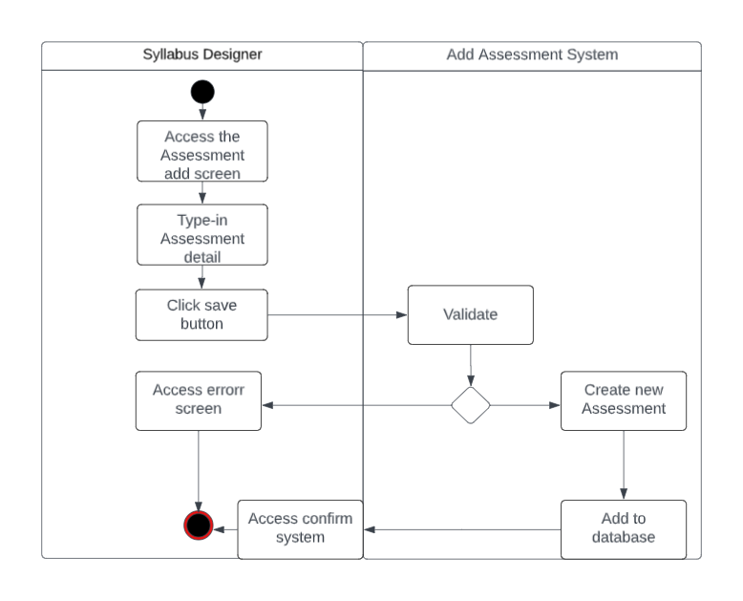

#### b. Prototype/Mockup

##### New Assessment screen

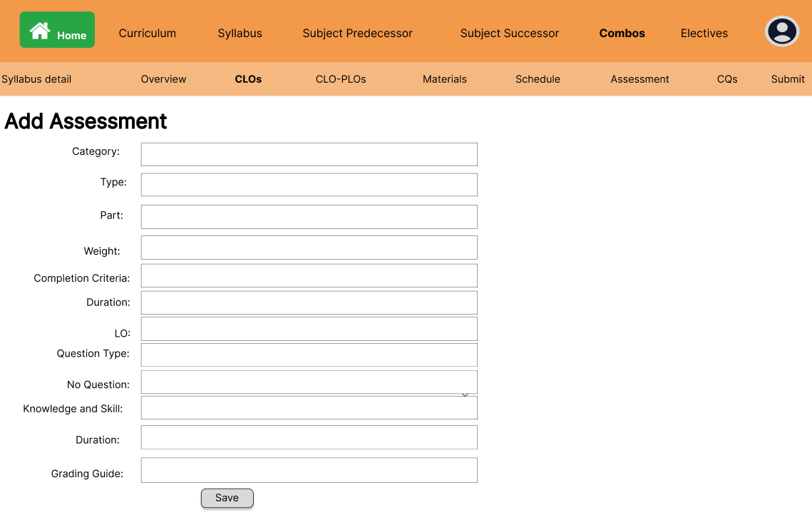

| **Field Name** | **Field Type** | **Description** |
| --- | --- | --- |
| Category | Value | Input value |
| Type | Value | Input value |
| Part | Value | Input value |
| Weight | Value | Input value |
| Completion Criteria | Value | Input value |
| Duration | Value | Input value |
| LO | Value | Input value |
| Question Type | Value | Input value |
| No Question | Value | Input value |
| Knowledge and Skill | Value | Input value |
| Duration | Value | Input value |
| Grading Guide | Value | Input value |
| Save | Button | User clicks to add new assessment |

#### c. Functional Description

#### 

| UC ID and Name: | **UC01 – Add new syllabus CLO** | | | | |
| --- | --- | --- | --- | --- | --- |
| Created By: | DungLm | | Date Created: | | 26/06/2023 |
| Primary Actor: | CRDD Staff,Syllabus Designer | | Secondary actor | | Add Assessment System |
| Trigger: | Click on the “new assessments ” button | | | | |
| Description: | Allow CRDD Staff, Syllabus Designer access to add new assessment | | | | |
| Preconditions: | The user must be logged-in as “Syllabus Designer” or “CRDD Staff” | | | | |
| Postconditions: | A new assessment is created in the system  The assessment created is edited by Syllabus Designer | | | | |
| Normal Flow: | ***Step*** | ***Step Details*** | | ***By*** | |
| 1 | Users click on button to view syllabus detail | | User | |
| 2 | Users click on the button to view assessment detail. | | User | |
| 3 | Users Click “add new” button | | User | |
| 4 | User input | | User | |
| 5 | Users add new assessment and click “add” button to save information | | User | |
| Alternative Flows: | *If the user does not enter a search keyword,*the system displays the entire syllabus.  If the staff click add, new assessment will be save | | | | |
| Exceptions: | If the web platform experiences technical issues or downtime, the system displays appropriate error messages and allows the user to try again later | | | | |
| Priority: | High | | | | |
| Frequency of Use: | Arable, depending on the user's need to access the curriculum | | | | |
| Business Rules: | BR1 | | | | |
| Other Information: | N/A | | | | |
| Assumptions: | The system ensures the privacy and security of user data and course information. | | | | |

#### d. Business Rules

#### 

| **ID** | **Business Rule** | **Business Rule Description** |
| --- | --- | --- |
| BR1 | Connection | Actor’s internet connection is available |

## 7. Combo Management UCs

### 7.1. UC019 - View Combo List

#### a. Activity Diagram

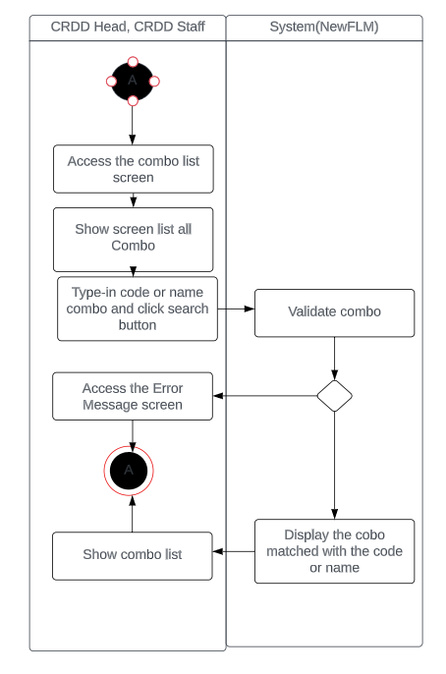

#### b. Prototype/Mockup combo code combo name action status filter theo status

##### View Combo List screen

##### 

| **Field Name** | **Field Type** | **Description** |
| --- | --- | --- |
| CurriCulum ID | Value | Displays the ID addresses of each curriculum according to the curriculum list |
| CurriCulum Code | Text Box | Give Curriculum codes by group |
| CurriCulum Name | Text Box | Name Combo of list curriculum |
| Combo ID | Value | Displays the ID addresses of each curriculum according to the curriculum list |
| Combo Name | Text Box | Display name Combo management according to curriculum code |
| Active | Choose item | Shows statuses still active or inactive |
| Activity | Button view  Button Update | Button view to see the information of the Elective management  Button update to update the information of the Elective management |

#### c. Functional Description

| UC ID and Name: | **UC19 – View Combo List** | | | | | |
| --- | --- | --- | --- | --- | --- | --- |
| Created By: | DanBS | | Date Created: | | 26/06/2023 | |
| Primary Actor: | CRDD Staff, CRDD Head | | Secondary Actors: | | System | |
| Trigger: | User clicks the “View Curriculum” and find by name according to CurriculumCode and clicks “View Combo” | | | | | |
| Description: | The function allows the user to view Curriculum list | | | | | |
| Preconditions: | The user must be connect internet | | | | | |
| Postconditions: | -The user successfully views the Curriculum DeTails.  -The user can view and refer to the Combo information. | | | | | |
| Normal Flow: | ***Step*** | ***Step Details*** | | ***By*** | | ***Business Rules*** |
| 1 | User enters the search keyword on the search box in “Curriculum List” page | | User | |  |
| 2 | User click the search button | | User | |  |
| 3 | System display the list of Curriculum Listing with the search keyword | | System | |  |
| 4 | Click the button “View Combo” at the bottom | | User | |  |
| 5 | Display view combo management | | System | |  |
| Alternative Flows: | ***4a. if the user does not enter a search keyword***  4a1. System display the entire curriculum details | | | | | |
| Exceptions: | None | | | | | |
| Priority: | High | | | | | |
| Frequency of Use: | Depending on the user’s need to the curriculum details | | | | | |
| Business Rules: | BR1 | | | | | |
| Other Information: | N/A | | | | | |
| Assumptions: | The system ensures the privacy and security of user data and course information. | | | | | |

#### d. Business Rules

| **ID** | **Business Rule** | **Business Rule Description** |
| --- | --- | --- |
| BR1 | Connection | Actor’s internet connect is available |

### 7.2 UC020 - Update Combo

#### a. Activity Diagram

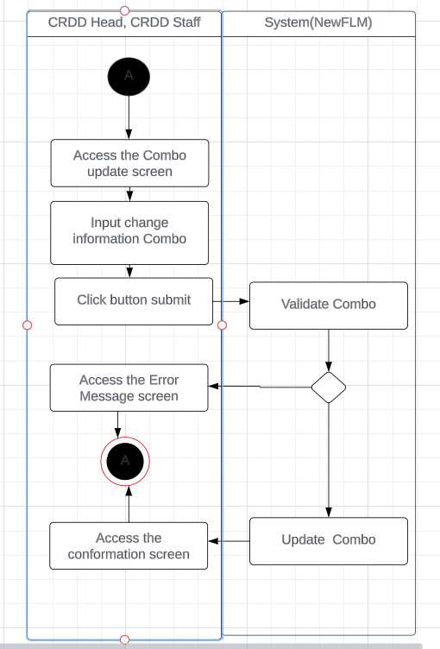

#### b. Prototype/Mockup

##### Update Combo screen

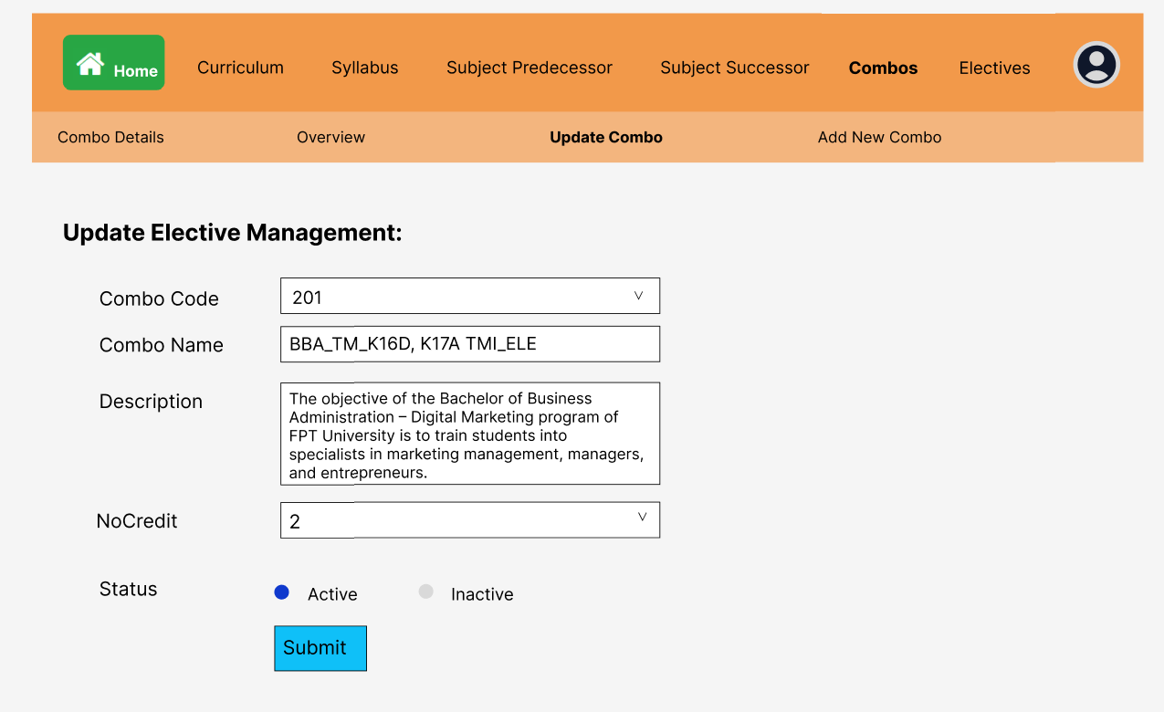

| **Field Name** | **Field Type** | **Description** |
| --- | --- | --- |
| Combo ID | Value | Displays the ID addresses of each curriculum according to the curriculum list |
| Combo Name | Text Box | Display name Combo management according to curriculum code |
| Description | Text Box | Overview of information related to elective manager |
| NoCredit | Text Box | This is for user to input total credit for elective |
| Status | Check Box | Display active or inactive information |

#### c. Functional Description

| UC ID and Name: | **UC20 – Update Combo** | | | | | |
| --- | --- | --- | --- | --- | --- | --- |
| Created By: | DanBS | | Date Created: | | 26/06/2023 | |
| Primary Actor: | CRDD Staff, CRDD Head | | Secondary Actors: | | System | |
| Trigger: | Click on the “update Combo“buttons | | | | | |
| Description: | Allow CRDD Staff, CRDD Head access to modify update combo | | | | | |
| Preconditions: | The user must be login as “CRDD Head’ or “CRDD Staff” | | | | | |
| Postconditions: | The curriculum created is edited by CRDD Staff  New curriculum is created tn the system | | | | | |
| Normal Flow: | ***Step*** | ***Step Details*** | | ***By*** | |  |
| 1 | CRDD Staff or CRDD Head have account and login successful | | CRDD Head or CRDD Staff | |
| 2 | CRDD Staff or CRDD Head click on button to view curriculum details | | CRDD Head or CRDD Staff | |
| 3 | CRDD Staff or CRDD Head click on the button “View Combo” | | CRDD Head or CRDD Staff | |
| 4 | CRDD Staff or CRDD Head update Combo and click “Submit” to save information | | CRDD Head or CRDD Staff | |
| Alternative Flows: | if the user does not enter a search keyword, the system displays the curriculum listing  if the staff click update Combo will be save | | | | | |
| Priority: | High | | | | | |
| Frequency of Use: | Arable , depending on the user’s need to access the curriculum | | | | | |
| Business Rules: | BR1 | | | | | |
| Other Information: | N/A | | | | | |
| Assumptions: | The system ensures the privacy and security of user data and course information. | | | | | |

#### d. Business Rules

| **ID** | **Business Rule** | **Business Rule Description** |
| --- | --- | --- |
| BR1 | Connection | Actor’s internet connect is available |

### 7.3 UC021 - Add New Combo

#### a. Activity Diagram

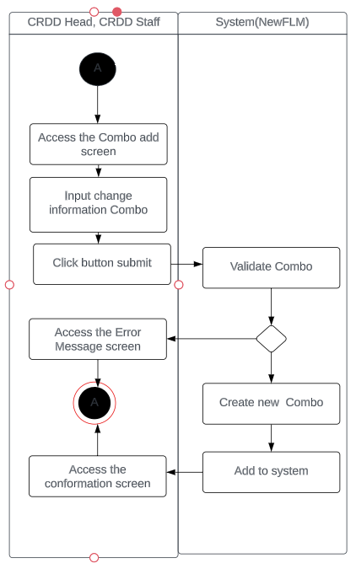

#### b. Prototype/Mockup

##### Add New Curriculum screen

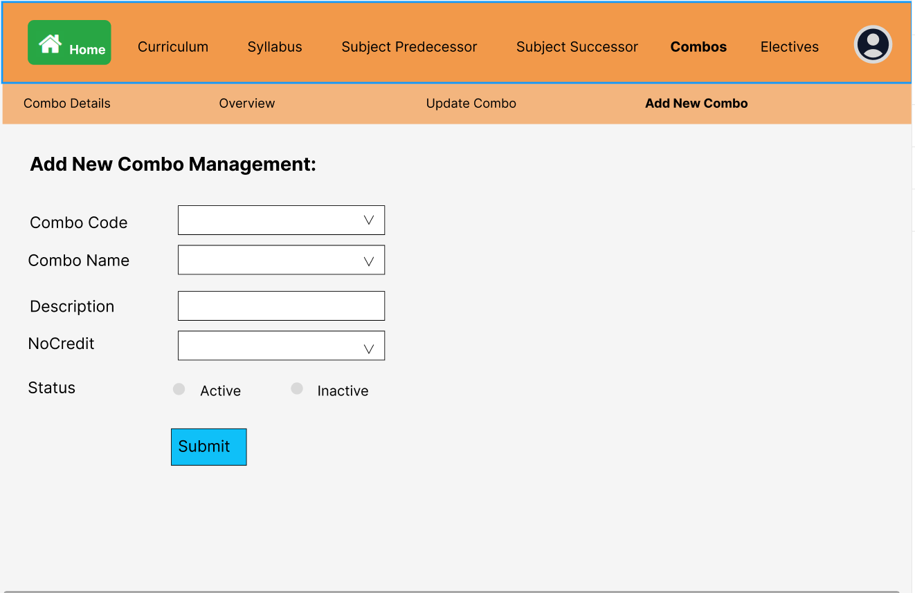

| **Field Name** | **Field Type** | **Description** |
| --- | --- | --- |
| Combo ID | Value | Displays the ID addresses of each curriculum according to the curriculum list |
| Combo Name | Text Box | Display name Combo management according to curriculum code |
| Description | Text Box | Overview of information related to elective manager |
| NoCredit | Text Box | This is for user to input total credit for elective |
| Status | Check Box | Display active or inactive information |

#### c. Functional Description

| UC ID and Name: | **UC21 – Add New Combo** | | | | | |
| --- | --- | --- | --- | --- | --- | --- |
| Created By: | DanBS | | Date Created: | | 26/06/2023 | |
| Primary Actor: | CRDD Staff, CRDD Head | | Secondary Actors: | | System | |
| Trigger: | Click on the “Add Combo” button | | | | | |
| Description: | Allow CRDD Staff, CRDD Head access to add new Combo | | | | | |
| Preconditions: | The curriculum created is edited by CRDD Staff  New curriculum is created tn the system | | | | | |
| Postconditions: | A new user is created in the system  The user created is granted the privileges as specified  The user created is created with a unique 4-digit employee number and a default password | | | | | |
| Normal Flow: | ***Step*** | ***Step Details*** | | ***By*** | | ***Business Rules*** |
| 1 | CRDD Staff or CRDD Head have account and login successful | | CRDD Head or CRDD Staff | |  |
| 2 | CRDD Staff or CRDD Head click on button to view curriculum details | | CRDD Head or CRDD Staff | |  |
| 3 | CRDD Staff or CRDD Head click on the button “View Combo” | | CRDD Head or CRDD Staff | |  |
| 4 | CRDD Staff or CRDD Head add new Combo and click “Submit” to save information | | CRDD Head or CRDD Staff | |  |
| Alternative Flows: | if the user does not enter a search keyword, the system displays the curriculum listing  if the staff click add new Combo will be save | | | | | |
| Exceptions: | None | | | | | |
| Priority: | High | | | | | |
| Frequency of Use: | Arable , depending on the user’s need to access the curriculum | | | | | |
| Business Rules: | BR1 | | | | | |
| Other Information: | N/A | | | | | |
| Assumptions: | The system ensures the privacy and security of user data and course information. | | | | | |

#### d. Business Rules

| **ID** | **Business Rule** | **Business Rule Description** |
| --- | --- | --- |
| BR1 | Connection | Actor’s internet connection is available |

## 8. Elective Management UCs

### 8.1. UC022 - View Elective List

#### a. Activity Diagram

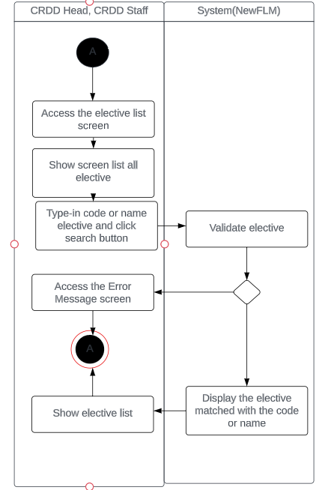

#### b. Prototype/Mockup

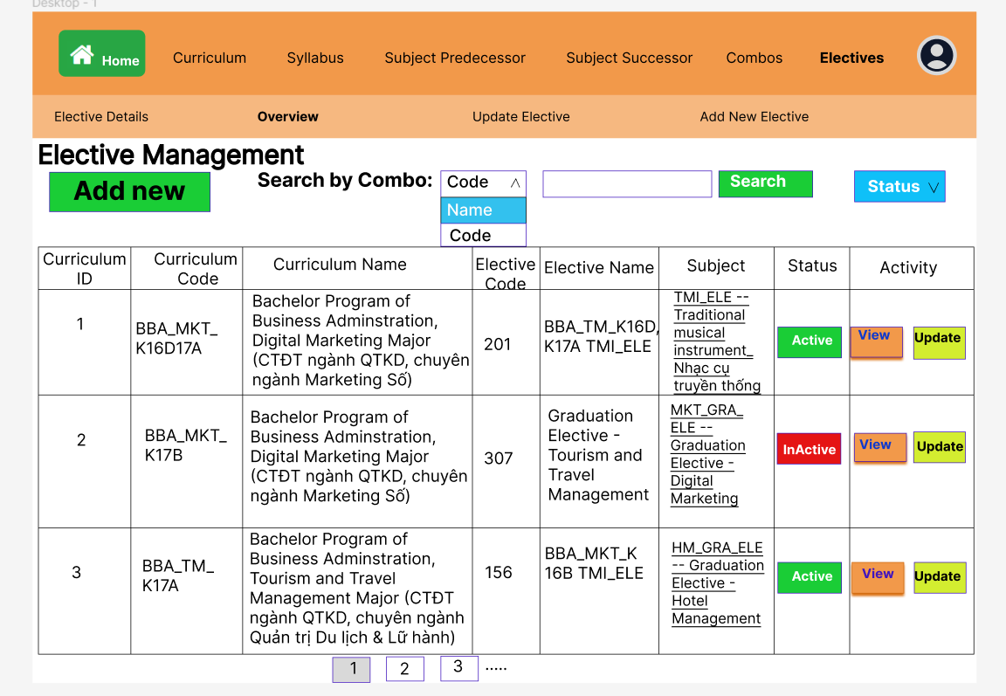

##### View Elective Management screen

| **Field Name** | **Field Type** | **Description** |
| --- | --- | --- |
| CurriCulum ID | Value | Displays the ID addresses of each curriculum according to the curriculum list |
| CurriCulum Code | Text Box | Give Curriculum codes by group |
| CurriCulum Name | Text Box | Name Combo of list curriculum |
| Elective ID | Value | Displays the ID addresses of each curriculum according to the curriculum list |
| Elective Name | Text Box | Display name Combo management according to curriculum code |
| Subject | Text Box | Display subject according to curriculum code |
| Status | Choose item | Shows statuses still active or inactive |
| Activity | Button view  Button Update | Button view to see the information of the Elective management  Button update to update the information of the Elective management |

#### c. Functional Description

#### 

| UC ID and Name: | **UC19 – View Elective List** | | | | | |
| --- | --- | --- | --- | --- | --- | --- |
| Created By: | DanBS | | Date Created: | | 26/06/2023 | |
| Primary Actor: | All users | | Secondary Actors: | | System | |
| Trigger: | User clicks the “Curriculum” and find by name according to CurriculumCode and clicks “View Elective” | | | | | |
| Description: | The function allows the user to view Curriculum list | | | | | |
| Preconditions: | The user must be connect internet | | | | | |
| Postconditions: | -The user successfully views the Curriculum DeTails.  -The user can view and refer to the Elective information. | | | | | |
| Normal Flow: | ***Step*** | ***Step Details*** | | ***By*** | | ***Business Rules*** |
| 1 | User enters the search keyword on the search box in “Curriculum List” page | | User | |  |
| 2 | User click the search button | | User | |  |
| 3 | System display the list of Curriculum Listing with the search keyword | | System | |  |
| 4 | Click the button “View Elective” at the bottom | | User | |  |
| 5 | Display view combo management | | System | |  |
| Alternative Flows: | ***4a. if the user does not enter a search keyword***  4a1. System display the entire curriculum details | | | | | |
| Exceptions: | None | | | | | |
| Priority: | High | | | | | |
| Frequency of Use: | Depending on the user’s need to the curriculum details | | | | | |
| Business Rules: | BR1 | | | | | |
| Other Information: | N/A | | | | | |
| Assumptions: | The system ensures the privacy and security of user data and course information. | | | | | |

#### d. Business Rules

| **ID** | **Business Rule** | **Business Rule Description** |
| --- | --- | --- |
| BR1 | Connection | Actor’s internet connect is available |

#### d. Business Rules

### 8.2 UC023 - Update Elective

#### a. Activity Diagram

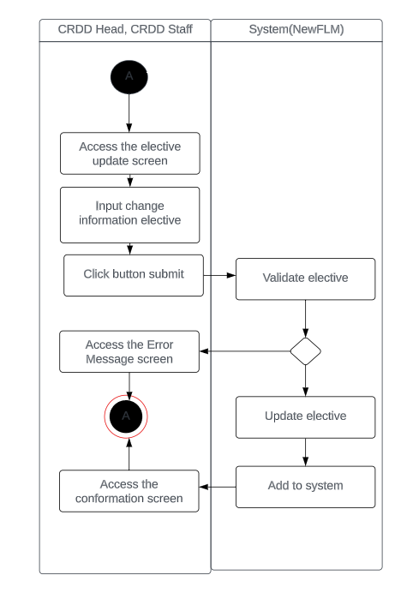

#### b. Prototype/Mockup

##### Update Elective screen

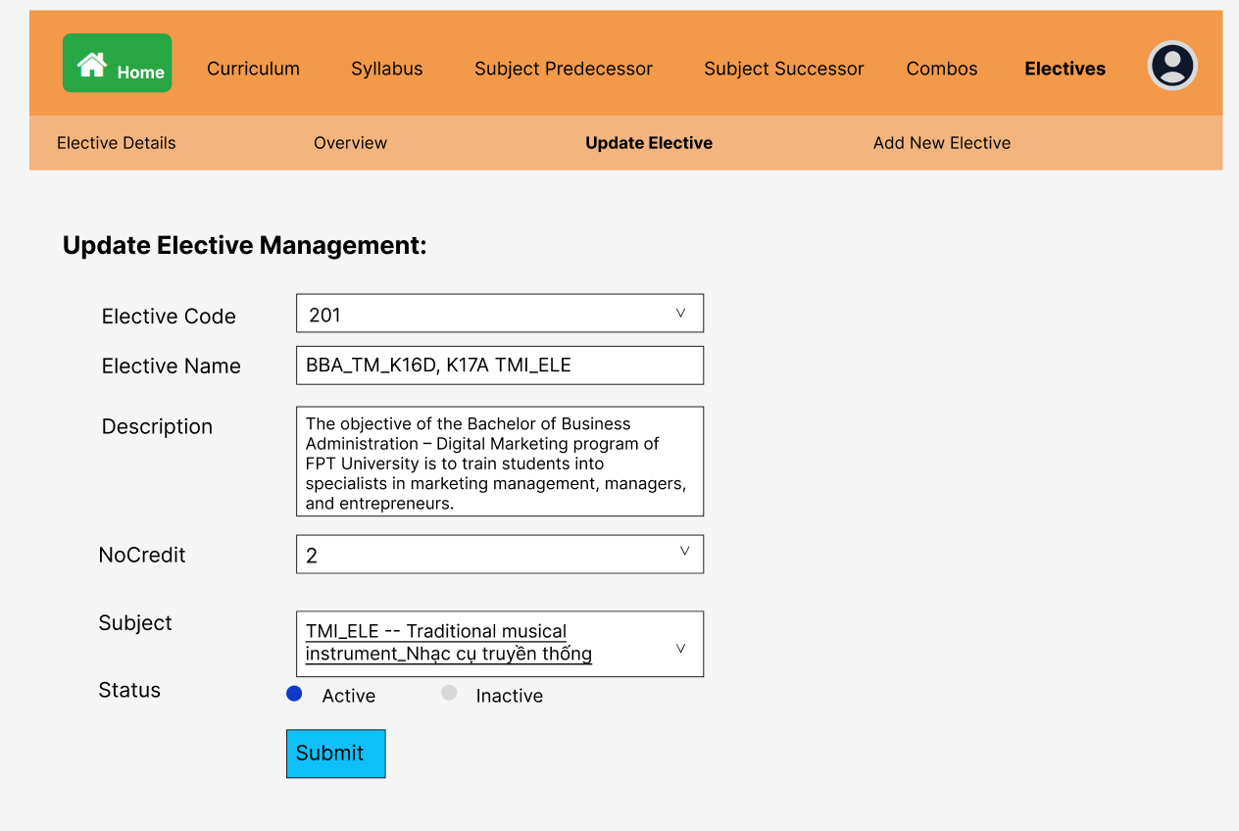

| **Field Name** | **Field Type** | **Description** |
| --- | --- | --- |
| Elective Code | Value | Displays the code addresses of each curriculum according to the curriculum list |
| Elective Name | Text Box | Display name elective management according to curriculum code |
| Subject | Text Box | Display subject according to curriculum code |
| Description | Text Box | Overview of information related to elective manager |
| NoCredit | Text Box | This is for user to input total credit for elective |
| Status | Check Box | Display active or inactive information |

#### c. Functional Description

| UC ID and Name: | **UC20 – Update Elective** | | | | | |
| --- | --- | --- | --- | --- | --- | --- |
| Created By: | DanBS | | Date Created: | | 26/06/2023 | |
| Primary Actor: | CRDD Staff, CRDD Head | | Secondary Actors: | | System | |
| Trigger: | Click on the “update Elective“buttons | | | | | |
| Description: | Allow CRDD Staff, CRDD Head access to modify update combo | | | | | |
| Preconditions: | The user must be login as “CRDD Head’ or “CRDD Staff” | | | | | |
| Postconditions: | The curriculum created is edited by CRDD Staff  New curriculum is created tn the system | | | | | |
| Normal Flow: | ***Step*** | ***Step Details*** | | ***By*** | |  |
| 1 | CRDD Staff or CRDD Head have account and login successful | | CRDD Head or CRDD Staff | |
| 2 | CRDD Staff or CRDD Head click on button to view curriculum details | | CRDD Head or CRDD Staff | |
| 3 | CRDD Staff or CRDD Head click on the button “View Combo” | | CRDD Head or CRDD Staff | |
| 4 | CRDD Staff or CRDD Head update Elective and click “Submit” to save information | | CRDD Head or CRDD Staff | |
| Alternative Flows: | if the user does not enter a search keyword, the system displays the curriculum listing  if the staff click update Elective will be save | | | | | |
| Priority: | High | | | | | |
| Frequency of Use: | Arable , depending on the user’s need to access the curriculum | | | | | |
| Business Rules: | BR1 | | | | | |
| Other Information: | N/A | | | | | |
| Assumptions: | The system ensures the privacy and security of user data and course information. | | | | | |

#### d. Business Rules

| **ID** | **Business Rule** | **Business Rule Description** |
| --- | --- | --- |
| BR1 | Connection | Actor’s internet connect is available |

### 8.3 UC024 - Add New Elective

#### a. Activity Diagram

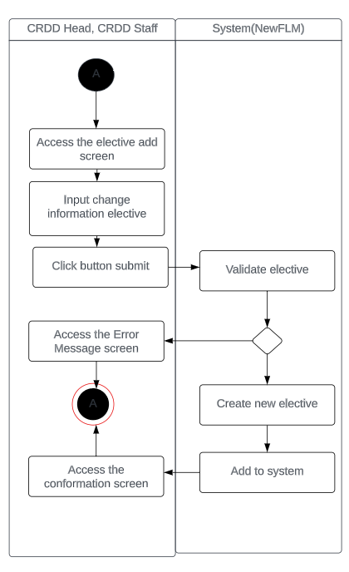

#### b. Prototype/Mockup

##### Add New Elective screen

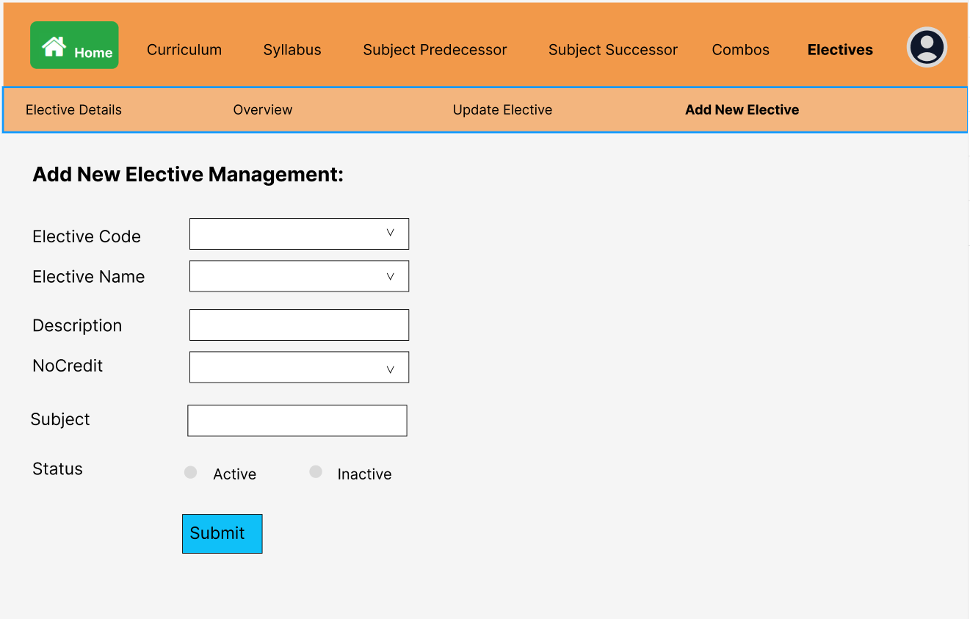

| **Field Name** | **Field Type** | **Description** |
| --- | --- | --- |
| Elective Code | Value | Displays the code addresses of each curriculum according to the curriculum list |
| Elective Name | Text Box | Display name elective management according to curriculum code |
| Subject | Text Box | Display subject according to curriculum code |
| Description | Text Box | Overview of information related to elective manager |
| NoCredit | Text Box | This is for user to input total credit for elective |
| Status | Check Box | Display active or inactive information |

#### c. Functional Description

| UC ID and Name: | **UC21 – Add Combo** | | | | | |
| --- | --- | --- | --- | --- | --- | --- |
| Created By: | DanBS | | Date Created: | | 26/06/2023 | |
| Primary Actor: | CRDD Staff, CRDD Head | | Secondary Actors: | | System | |
| Trigger: | Click on the “Add Elective” button | | | | | |
| Description: | Allow CRDD Staff, CRDD Head access to add new Elective | | | | | |
| Preconditions: | The curriculum created is edited by CRDD Staff  New curriculum is created tn the system | | | | | |
| Postconditions: | A new user is created in the system  The user created is granted the privileges as specified  The user created is created with a unique 4-digit employee number and a default password | | | | | |
| Normal Flow: | ***Step*** | ***Step Details*** | | ***By*** | | ***Business Rules*** |
| 1 | CRDD Staff or CRDD Head have account and login successful | | CRDD Head or CRDD Staff | |  |
| 2 | CRDD Staff or CRDD Head click on button to view curriculum details | | CRDD Head or CRDD Staff | |  |
| 3 | CRDD Staff or CRDD Head click on the button “View Elective” | | CRDD Head or CRDD Staff | |  |
| 4 | CRDD Staff or CRDD Head add new Combo and click “Submit” to save information | | CRDD Head or CRDD Staff | |  |
| Alternative Flows: | ***if the user does not enter a search keyword, the system displays the curriculum listing***  ***if the staff click add new Elective will be save*** | | | | | |
| Exceptions: | None | | | | | |
| Priority: | High | | | | | |
| Frequency of Use: | Arable , depending on the user’s need to access the curriculum | | | | | |
| Business Rules: | BR1 | | | | | |
| Other Information: | N/A | | | | | |
| Assumptions: | The system ensures the privacy and security of user data and course information. | | | | | |

#### d. Business Rules

| **ID** | **Business Rule** | **Business Rule Description** |
| --- | --- | --- |
| BR1 | Connection | Actor’s internet connect is available |

## 9. Curriculum Subject UCS

### 9.1. UC025 - View Curriculum Subject List

#### a. Activity Diagram

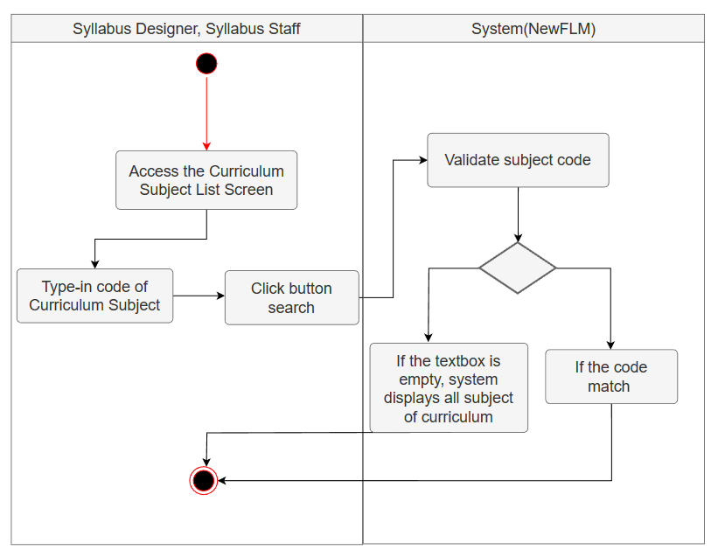

#### b. Prototype/Mockup

##### Curriculum subject list screen

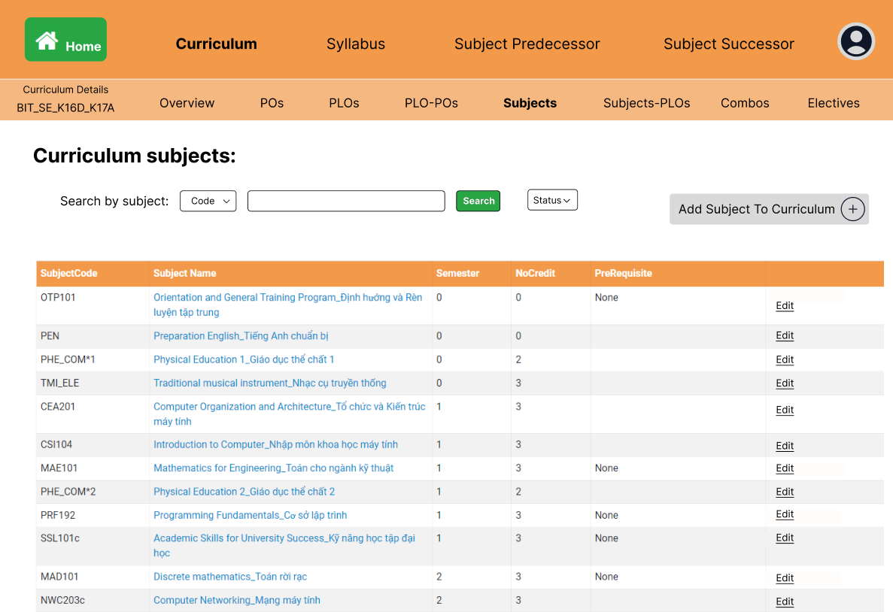

| **Field Name** | **Field Type** | **Description** |
| --- | --- | --- |
| Curriculum Code | Text Box | This is for user to choose code of curriculum |
| Search by subject | Text Box | This is for user search subject of this curriculum |
| Add | Button | The user presses the button to add PLO curriculum |
| Edit | Button | The user presses the button to edit PLO curriculum information |

#### c. Functional Description

#### 

| UC ID and Name: | **UC025 – View Curriculum Subject List** | | | | | |
| --- | --- | --- | --- | --- | --- | --- |
| Created By: | NamDH | | Date Created: | | 26/06/2023 | |
| Primary Actor: | **Syllabus Designer** | | Secondary Actors: | |  | |
| Trigger: | User clicks the “Curriculum” link from the User List screen, or  User chooses “Curriculum List” menu from NavBar (sider) tree-menu | | | | | |
| Description: | The function allows the user to view the curriculum list. | | | | | |
| Preconditions: | The user must be connection internet | | | | | |
| Postconditions: | * The user successfully views the curriculum information. * The user can access and refer to the curriculum information as needed. | | | | | |
| Normal Flow: | ***Step*** | ***Step Details*** | | ***By*** | | ***Business Rules*** |
| 1 | User enters the search keyword on the search box in navigation. | | User | |  |
| 2 | Users click the search button. | | User | |  |
| 3 | System displays the list of curriculum code matched with the search keyword. | | System | |  |
| 4 | Display curriculum subject | | System | | FR1 |
| Alternative Flows: | ***1. If the user does not enter a search keyword***  1.1. The system displays the entire curriculum. | | | | | |
| Exceptions: | If the web platform experiences technical issues or downtime, the system displays appropriate error messages and allows the user to try again later | | | | | |
| Priority: | High | | | | | |
| Frequency of Use: | Arable, depending on the user's need to access the curriculum | | | | | |
| Business Rules: | BR1 | | | | | |
| Other Information: | N/A | | | | | |
| Assumptions: | The system ensures the privacy and security of user data and course information. | | | | | |

#### d. Business Rules

#### 

| **ID** | **Business Rule** | **Business Rule Description** |
| --- | --- | --- |
| FR1 | All users with appropriate permissions can view the list of curriculum subjects. | This use case allows users to access and view the existing assessments linked to a syllabus. The list should provide an overview of each assessment, including its title, type, weightage, and other relevant information. |

### 9.2 UC026 - Update Curriculum Subject

#### a. Activity Diagram

#### b. Prototype/Mockup

##### Update Curriculum subject list screen

| **Field Name** | **Field Type** | **Description** |
| --- | --- | --- |
| Search | Text Box | This is for user to input code of curriculum subject |
| Semester | Combo Box | This is for user to select number of semester for curriculum subject |
| NoCredit | Combo Box | This is for user to select number of NoCredit for curriculum subject |
| PreRequisite | Text Box | This is for user to input name of subject requisite |
| Update | Button | The user presses the button to save the information |

#### c. Functional Description

#### 

| UC ID and Name: | **UC26 – Update Curriculum** | | | | | |
| --- | --- | --- | --- | --- | --- | --- |
| Created By: | NamDH | | Date Created: | | 26/06/2023 | |
| Primary Actor: | **Syllabus Designer** | | Secondary Actors: | | CRDD Head | |
| Trigger: | User clicks the “Manage Curriculum” button from the NavBar (sider) tree-menu then click “ Edit Curriculum” button | | | | | |
| Description: | The purpose of this use case is to update a curriculum | | | | | |
| Preconditions: | The user must be logged-in as “CRDD Head or CRDD Staff ” | | | | | |
| Postconditions: | The curriculum is updated in the system  The curriculum is edited by CRDD Staff and CRDD Designer. | | | | | |
| Normal Flow: | ***Step*** | ***Step Details*** | | ***By*** | | ***Business Rules*** |
| 1 | Access the Edit Curriculum screen | | User | | FR1 |
| 2 | Editing curriculum information | | User | | FR1, BR1,BR2 |
| 3 | Click the Save button | | User | |  |
| 4 | Validate curriculum subject details | | System | |  |
| 5 | Updated curriculum | | System | |  |
| 6 | Notification of successful | | System | | BR4 |
| 7 | Back to the Manage Curriculum Subject screen | | System | |  |
| Alternative Flows: | ***a. Curriculum details validation fails***  a1. System shows the Error Message screen  a2. User comes back to the step 2 | | | | | |
| Exceptions: | None | | | | | |
| Priority: | High | | | | | |
| Frequency of Use: | Depends on the frequency of changes in the system | | | | | |
| Business Rules: |  | | | | | |
| Other Information: |  | | | | | |
| Assumptions: |  | | | | | |

#### d. Business Rules

#### 

| **ID** | **Business Rule** | **Business Rule Description** |
| --- | --- | --- |
| FR1 | Access Control | The system should verify the user's access rights before allowing them to proceed to the edit subject screen. If the user is unauthorized, an error message or access denial should be displayed. |
| BR1 | Prerequisite Subject Validation | The system should check if the prerequisite subject exists in the system and is a valid subject. If the prerequisite subject is not found or is invalid, the user should be notified through an error message. |
| BR2 | Semester, NoCredit | The system should ensure that the selected number exists in the system and is available for assignment to the subject. If the number is not valid or cannot be assigned, an appropriate error message should be displayed. |
| BR3 | Code Validation | The system should check that the subject code is provided and adheres to any required format or restrictions. If the code is missing or does not meet the specified criteria, an error message should be displayed. |
| BR4 | Data Persistence | Upon successful validation, the system should add the subject with its corresponding information to the database, ensuring data integrity and persistence. |

### 9.3 UC027 - Add Curriculum Subject

#### a. Activity Diagram

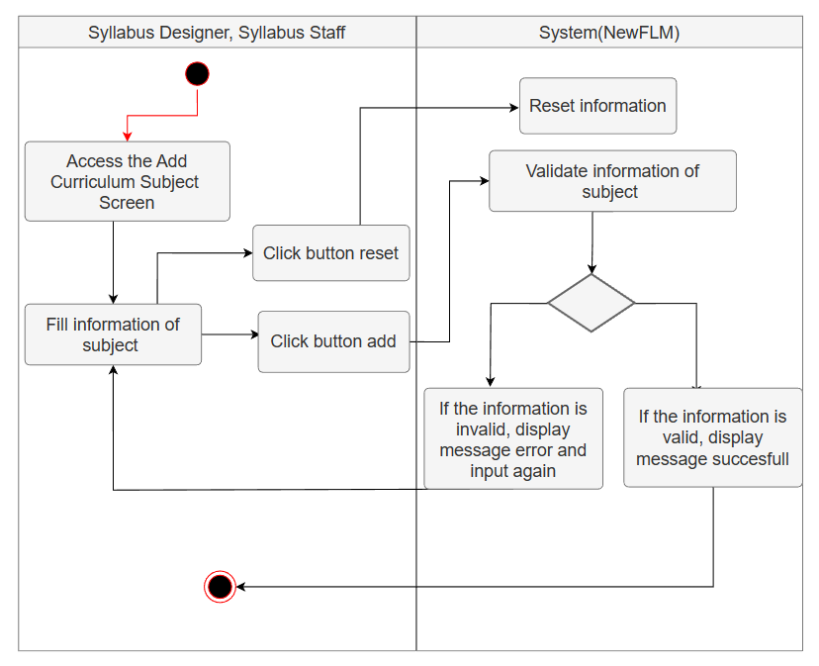

#### b. Prototype/Mockup bỏ pre thêm descrip thêm phần navbar

##### Add New Curriculum subject list screen

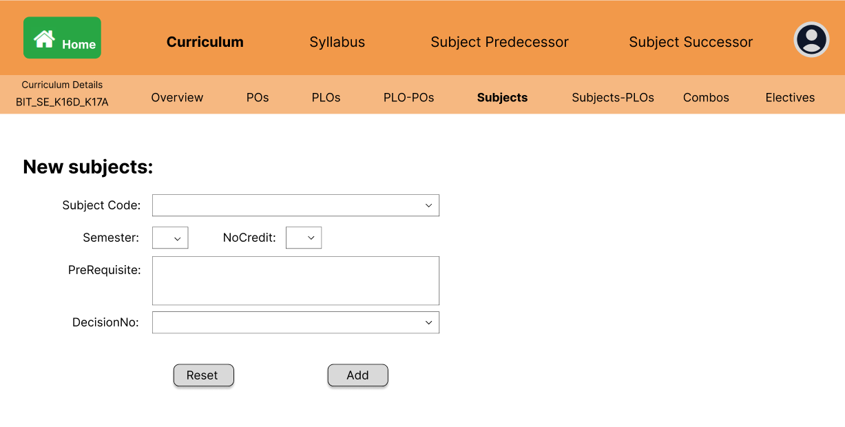

| **Field Name** | **Field Type** | **Description** |
| --- | --- | --- |
| Subject Code | Text Box | This is for user to input code of curriculum subject |
| Name | Text Box | This is for user to input name of curriculum subject |
| Semester | Combo Box | This is for user to select number of semester for curriculum subject |
| NoCredit | Combo Box | This is for user to select number of NoCredit for curriculum subject |
| PreRequisite | Text Box | This is for user to input name of subject requisite |
| Add | Button | The user presses the button to save the information |
| Reset | Button | The user presses the button to reset information entered |
| New | Button | The user presses the button to add one more subject to enter |

#### c. Functional Description

#### 

| UC ID and Name: | **UC27 – Add Curriculum Subject** | | | | | |
| --- | --- | --- | --- | --- | --- | --- |
| Created By: | NamDH | | Date Created: | | 26/06/2023 | |
| Primary Actor: | **Syllabus Designer** | | Secondary Actors: | | CRDD Staff | |
| Trigger: | User clicks the “Manage Curriculum” button from the NavBar (sider) tree-menu then click “ Add New Curriculum” button | | | | | |
| Description: | The purpose of this use case is to create a new curriculum in the system | | | | | |
| Preconditions: | The user must be logged-in as “CRDD Head or CRDD Staff” | | | | | |
| Postconditions: | A new curriculum is created in the system  The curriculum created is edited by CRDD Staff and CRDD Designer | | | | | |
| Normal Flow: | ***Step*** | ***Step Details*** | | ***By*** | | ***Business Rules*** |
| 1 | Access the Add Curriculum Subject screen | | User | | FR1 |
| 2 | Type-in subject code, name , choose semester, noCredit and fill PreRequisite | | User | | FR1,BR1,BR2,BR3 |
| 3 | Click the Save button | | User | |  |
| 4 | Validate curriculum subject name | | System | |  |
| 5 | Create new curriculum subject | | System | |  |
| 6 | Notification of successful creation | | System | | BR4 |
| 7 | Back to the Manage Curriculum screen | | System | |  |
| Alternative Flows: | ***4a. Curriculum Subject name validation fails***  4a1. System shows the Error Message screen  4a2. User comes back to the step 2 | | | | | |
| Exceptions: | None | | | | | |
| Priority: | Medium | | | | | |
| Frequency of Use: | Depends on the frequency of changes in the system | | | | | |
| Business Rules: | N/A | | | | | |
| Other Information: |  | | | | | |
| Assumptions: |  | | | | | |

#### d. Business Rules

| **ID** | **Business Rule** | **Business Rule Description** |
| --- | --- | --- |
| FR1 | Access Control | The system should verify the user's access rights before allowing them to proceed to the edit subject screen. If the user is unauthorized, an error message or access denial should be displayed. |
| BR1 | Prerequisite Subject Validation | The system should check if the prerequisite subject exists in the system and is a valid subject. If the prerequisite subject is not found or is invalid, the user should be notified through an error message. |
| BR2 | Semester, NoCredit | The system should ensure that the selected number exists in the system and is available for assignment to the subject. If the number is not valid or cannot be assigned, an appropriate error message should be displayed. |
| BR3 | Code Validation | The system should check that the subject code is provided and adheres to any required format or restrictions. If the code is missing or does not meet the specified criteria, an error message should be displayed. |
| BR4 | Data Persistence | Upon successful validation, the system should add the subject with its corresponding information to the database, ensuring data integrity and persistence. |

## 10. Curriculum Subject PLO UCs

### 10.1. UC028 - View Curriculum Subject PLO List

#### a. Activity Diagram

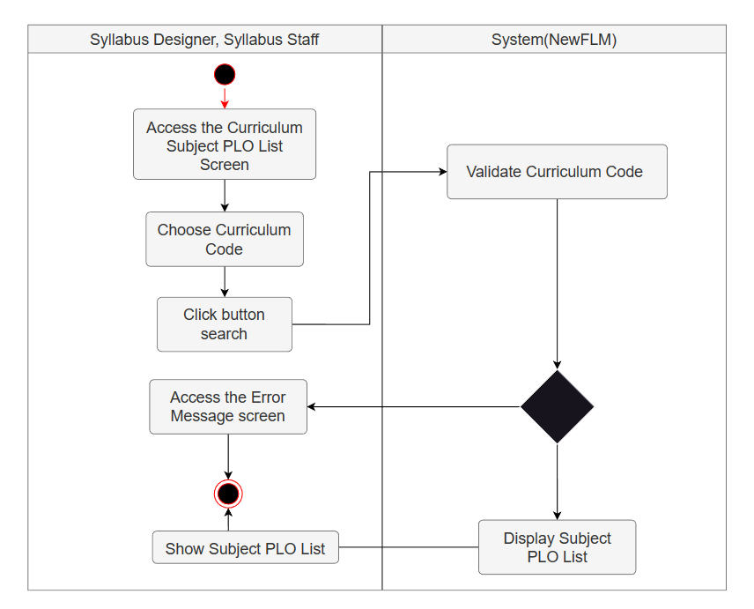

#### b. Prototype/Mockup

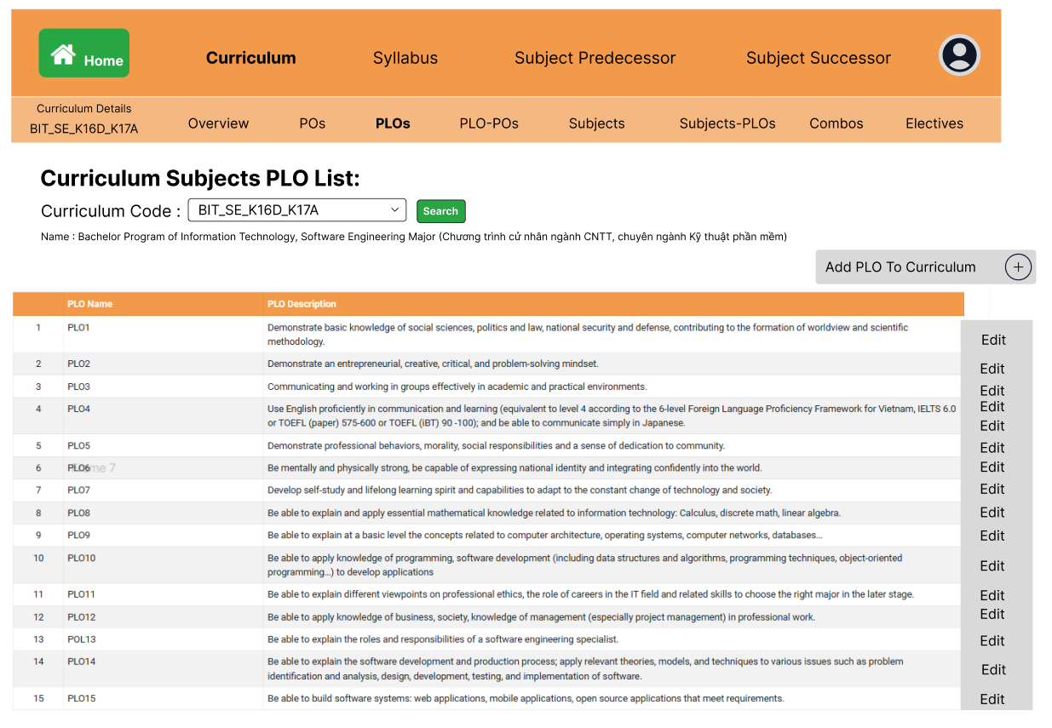

| **Field Name** | **Field Type** | **Description** |
| --- | --- | --- |
| Curriculum Code | Text Box | This is for user to choose code of curriculum |
| Add | Button | The user presses the button to add PLO curriculum |
| Edit | Button | The user presses the button to edit PLO curriculum information |

#### c. Functional Description

#### 

| UC ID and Name: | **UC028 – View Curriculum Subject List** | | | | | |
| --- | --- | --- | --- | --- | --- | --- |
| Created By: | NamDH | | Date Created: | | 26/06/2023 | |
| Primary Actor: | **Syllabus Designer** | | Secondary Actors: | |  | |
| Trigger: | User clicks the “Curriculum PLO” link from the User List screen, or  User chooses “Curriculum PLO List ” menu from NavBar (sider) tree-menu | | | | | |
| Description: | The function allows the user to view the curriculum list. | | | | | |
| Preconditions: | The user must be connection internet | | | | | |
| Postconditions: | * The user successfully views the curriculum information. * The user can access and refer to the curriculum information as needed. | | | | | |
| Normal Flow: | ***Step*** | ***Step Details*** | | ***By*** | | ***Business Rules*** |
| 1 | User enters the search keyword on the search box in navigation. | | User | |  |
| 2 | Users click the search button. | | User | |  |
| 3 | System displays the list of curriculum code matched with the search keyword. | | System | |  |
| 4 | Display curriculum subject PLO | | System | | FR1 |
| Alternative Flows: | ***1. If the user does not enter a search keyword***  1.1. The system displays the entire curriculum. | | | | | |
| Exceptions: | If the web platform experiences technical issues or downtime, the system displays appropriate error messages and allows the user to try again later | | | | | |
| Priority: | High | | | | | |
| Frequency of Use: | Arable, depending on the user's need to access the curriculum | | | | | |
| Business Rules: | BR1 | | | | | |
| Other Information: | N/A | | | | | |
| Assumptions: | The system ensures the privacy and security of user data and course information. | | | | | |

#### d. Business Rules

#### 

| **ID** | **Business Rule** | **Business Rule Description** |
| --- | --- | --- |
| FR1 | All users with appropriate permissions can view the list of curriculum subjects. | This use case allows users to access and view the existing assessments linked to a syllabus. The list should provide an overview of each assessment, including its title, type, weightage, and other relevant information. |

### 10.2 UC029 - Update Curriculum Subject PLO

#### a. Activity Diagram

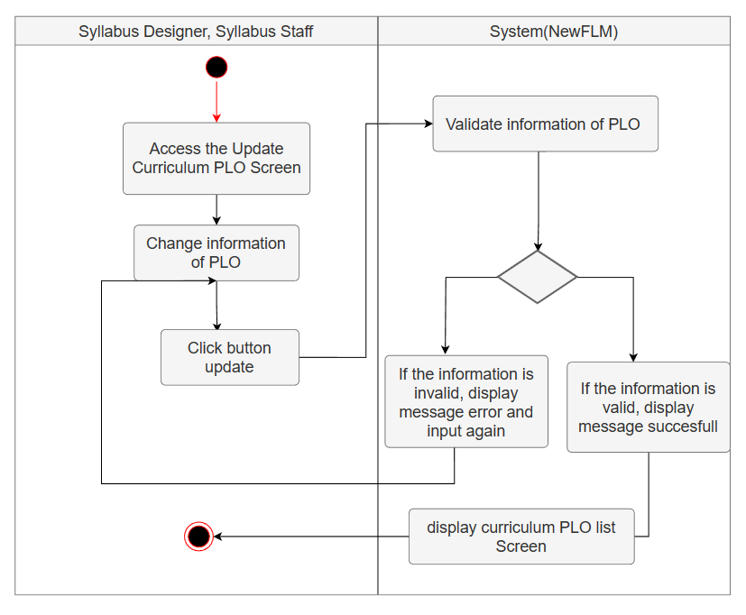

#### b. Prototype/Mockup

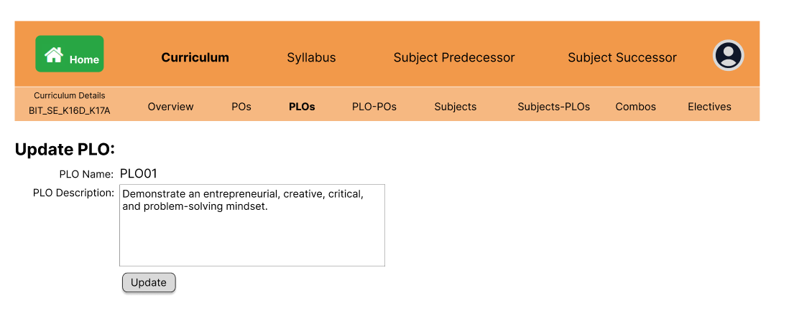

| **Field Name** | **Field Type** | **Description** |
| --- | --- | --- |
| Search Subject Code | Text Box | This is for user to input code of curriculum subject |
| PLO Description | Text Box | This is for user to input or edit description of Curriculum PLO |
| Update | Button | The user presses the button to add information of Curriculum PLO |

#### c. Functional Description

#### 

| UC ID and Name: | **UC29 – Update Curriculum PLO** | | | | | |
| --- | --- | --- | --- | --- | --- | --- |
| Created By: | NamDH | | Date Created: | | 26/06/2023 | |
| Primary Actor: | **Syllabus Designer** | | Secondary Actors: | | CRDD Head | |
| Trigger: | User clicks the “Manage Curriculum PLO” button from the NavBar (sider) tree-menu then click “ Edit Curriculum PLO” button | | | | | |
| Description: | The purpose of this use case is to update a curriculum | | | | | |
| Preconditions: | The user must be logged-in as “Syllabus Designer ” | | | | | |
| Postconditions: | The curriculum PLO is updated in the system  The curriculum PLO is edited by Syllabus Designer. | | | | | |
| Normal Flow: | ***Step*** | ***Step Details*** | | ***By*** | | ***Business Rules*** |
| 1 | Access the Edit Curriculum PLO screen | | User | | FR1 |
| 2 | System display current information | | System | | BR1 |
| 3 | Editing curriculum PLO information | | User | | BR2,FR1 |
| 4 | Click the Save button | | User | |  |
| 5 | Validate curriculum PLO details | | System | |  |
| 6 | Updated curriculum PLO | | System | |  |
| 7 | Notification of successful | | System | | BR4 |
| 8 | Back to the Manage Curriculum screen | | System | |  |
| Alternative Flows: | ***a. Curriculum details validation fails***  a1. System shows the Error Message screen  a2. User comes back to the step 2 | | | | | |
| Exceptions: | None | | | | | |
| Priority: | High | | | | | |
| Frequency of Use: | Depends on the frequency of changes in the system | | | | | |
| Business Rules: |  | | | | | |
| Other Information: |  | | | | | |
| Assumptions: |  | | | | | |

#### d. Business Rules

#### 

| **ID** | **Business Rule** | **Business Rule Description** |
| --- | --- | --- |
| FR1 | Access Control | The system should verify the user's access rights before allowing them to proceed to the edit subject screen. If the user is unauthorized, an error message or access denial should be displayed. |
| BR1 | Prerequisite Subject Validation | The system should check if the prerequisite subject exists in the system and is a valid subject. If the prerequisite subject is not found or is invalid, the user should be notified through an error message. |
| BR2 | Field Validation | The system should check the user's input for each field against predetermined validation rules to ensure the data entered is valid and meets the required criteria. |
| BR3 | Code Validation | The system should check that the subject code is provided and adheres to any required format or restrictions. If the code is missing or does not meet the specified criteria, an error message should be displayed. |
| BR4 | Data Persistence | Upon successful validation, the system should add the subject with its corresponding information to the database, ensuring data integrity and persistence. |

### 10.3 UC030 - Add Curriculum Subject PLO

#### a. Activity Diagram

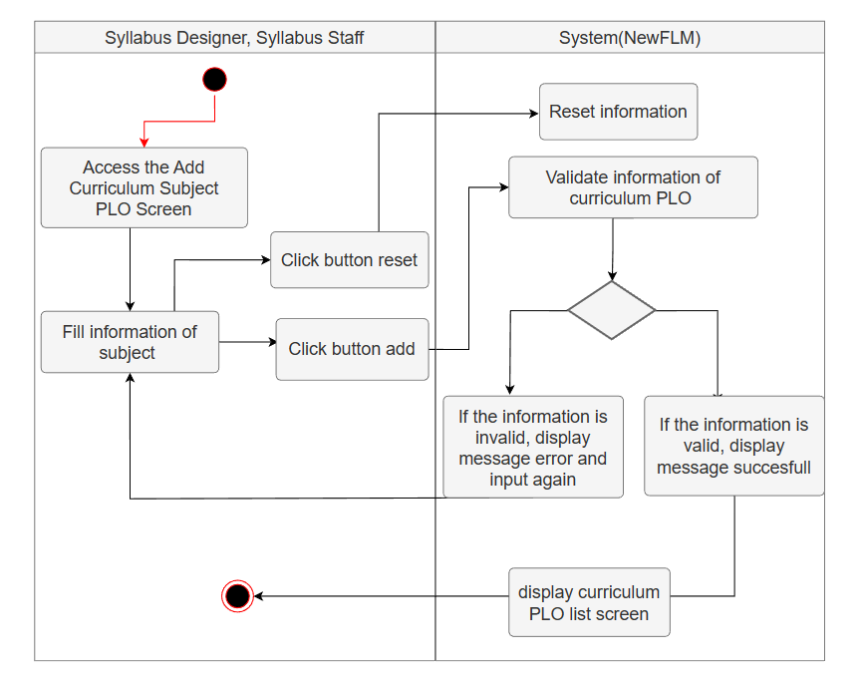

#### 

#### b. Prototype/Mockup

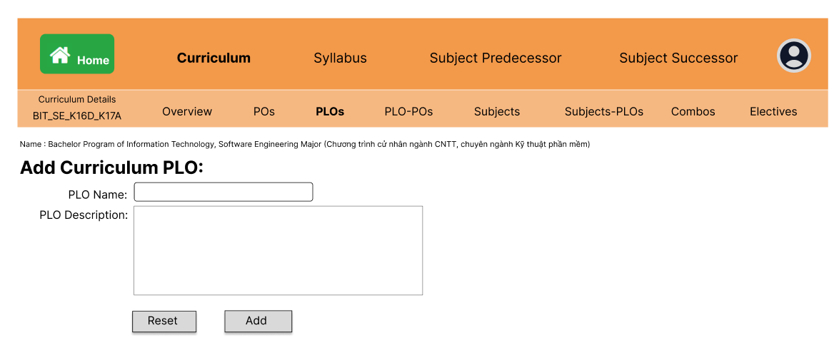

| **Field Name** | **Field Type** | **Description** |
| --- | --- | --- |
| PLO Name | Text Box | This is for user to input name of curriculum PLO |
| PLO Description | Text Box | This is for user to input description of Curriculum PLO |
| Add | Button | The user presses the button to save the information |
| Reset | Button | The user presses the button to reset information entered |
| New | Button | The user presses the button to add one more PLO to enter |

#### c. Functional Description

#### 

| UC ID and Name: | **UC30 – Add Curriculum PLO** | | | | | |
| --- | --- | --- | --- | --- | --- | --- |
| Created By: | NamDH | | Date Created: | | 26/06/2023 | |
| Primary Actor: | **Syllabus Designer** | | Secondary Actors: | | CRDD Staff | |
| Trigger: | User clicks the “Manage Curriculum” button from the NavBar (sider) tree-menu then click “ Add New Curriculum PLO” button | | | | | |
| Description: | The purpose of this use case is to create a new curriculum in the system | | | | | |
| Preconditions: | The user must be logged-in as “Syllabus Designer” | | | | | |
| Postconditions: | A new curriculum is created in the system  The curriculum PLO created is edited by Syllabus Designer | | | | | |
| Normal Flow: | ***Step*** | ***Step Details*** | | ***By*** | | ***Business Rules*** |
| 1 | Access the Add New Curriculum PLO screen | | User | | FR1 |
| 2 | Type-in the curriculum PLO name, PLO Description | | User | | BR2,BR3 |
| 3 | Click the Save button | | User | |  |
| 4 | Validate curriculum PLO name | | System | |  |
| 5 | Create new curriculum PLO | | System | |  |
| 6 | Notification of successful creation | | System | | BR4 |
| 7 | Back to the Manage Curriculum PLO screen | | System | |  |
| Alternative Flows: | ***4a. Curriculum PLO name validation fails***  4a1. System shows the Error Message screen  4a2. User comes back to the step 2 | | | | | |
| Exceptions: | None | | | | | |
| Priority: | Medium | | | | | |
| Frequency of Use: | Depends on the frequency of changes in the system | | | | | |
| Business Rules: | N/A | | | | | |
| Other Information: |  | | | | | |
| Assumptions: |  | | | | | |

#### d. Business Rules

#### 

| **ID** | **Business Rule** | **Business Rule Description** |
| --- | --- | --- |
| FR1 | Access Control | The system should verify the user's access rights before allowing them to proceed to the edit subject screen. If the user is unauthorized, an error message or access denial should be displayed. |
| BR1 | Data Retrieval and Display | The system should query the subject data based on the selected subject and populate the edit subject screen with the current subject's general information. |
| BR2 | Field Validation | The system should check the user's input for each field against predetermined validation rules to ensure the data entered is valid and meets the required criteria. |
| BR3 | Field-Specific Updates | The system should apply the changes made by the user to the specific field selected. The update should be performed accurately and consistently, reflecting the user's modifications. |
| BR4 | Data Persistence | After the user has made the desired changes, the system should store the updated subject information persistently in the database to reflect the modifications. |

### 

# III. Non-Functional Requirements

## 1. External Interfaces

### 1.1 User Interfaces

* UI-1: The GUI is compatible with both desktop and mobile display.
* UI-2: Use icons to provide visual insights for users.
* UI-3: Important commands and messages are displayed as buttons and labels with distinct background colors.

### 1.2 Software Interfaces

| **ID** | **Software Used** | **Description** |
| --- | --- | --- |
| 1 | OS | Any OS available now |
| 2 | ReactJs, HTML, CSS | Javascript library to build front-end |
| 3 | NodeJs, ExpressJs | Build backend |

#### 

### 1.3 Hardware Interfaces

* Any web browsers available now: Chrome, Firefox, Coc Coc, Ie.
* Internet
* Device that can connect website

### 1.4 Communications Interfaces

* This project supports all types of web browsers. We are using Facebook API to share post /our web to facebook
* The communication between the different parts of the web is important since they depend on each other. However, in what way the communication is achieved is not important for the web and is therefore handled by the underlying operating systems for the web portal

## 2. Quality Attributes

### 2.1 Usability

* Efficiency of use: goals are easy to accomplish quickly and with few or no user errors
* Intuitiveness: the interface is easy to learn and navigate; buttons, headings, and help/error messages are simple to understand
* Low perceived workload: the interface appears easy to use, rather than intimidating, demanding and frustrating

### 2.2 Security

* No user’s information, properties loss, insult from thirds party for bad behaviors
* When signing up, guests need to create an account with a real name, username must have more than 6 characters, password must have more than 8 characters included: letter, number. Guest need to agree with web site ‘s privacy

### 2.3 Performance

* Any response must be within 2 seconds or less
* After press any button, there’re always respond within 1 seconds (loading process, save success, etc)

### 2.4 Safety Requirements

* If there is extensive damage to a wide portion of the database due to catastrophic failure, such as a disk crash, the recovery method restores a past copy of the database that was backed up to archival storage (typically tape) and reconstructs a more current state by reapplying or redoing the operations of committed transactions from the backed up log, up to the time of failure.

# IV. Appendix

## 1. Assumptions & Dependencies

AS-1: Systems with appropriate user interfaces will be available for cafeteria employees to process the expected volume of meals ordered.

AS-2: Cafeteria staff and vehicles will be available to deliver all meals for specified delivery time slots within 15 minutes of the requested delivery time.

DE-1: If a restaurant has its own on-line ordering system, the Cafeteria Ordering System must be able to communicate with it bi-directionally.

## 2. Limitations & Exclusions

## 3. Business Rules